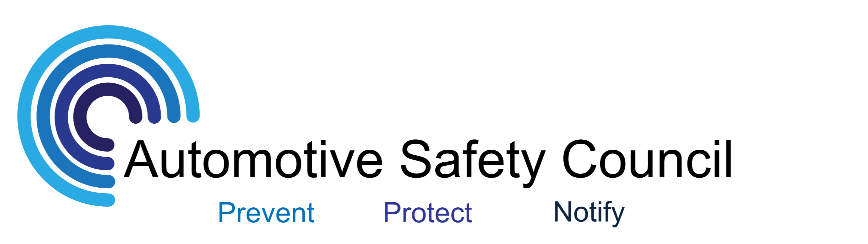

NHTSA Recalls of Interest
March 18, 2013

RECALL Subject : Occupant Detection System May Disable Pass Air Bag
Report Receipt Date: MAR 01, 2013
NHTSA Campaign Number: 13V069000
Component(s): AIR BAGS
Potential Number of Units Affected: 0
All Products Associated with this Recall
Vehicle Make - Model - Model Year(s)
- INFINITIJX352013
- NISSANALTIMA2013
- NISSANLEAF2013
- NISSANPATHFINDER2013
- NISSANSENTRA2013
Details
2 Associated Documents
Manufacturer: Nissan North America, Inc.
SUMMARY:
Nissan is recalling certain model year 2013 Altima, LEAF, Pathfinder, Sentra, and Infiniti JX35 vehicles. Sensors within the passenger Occupant Detection System (ODS) may have been manufactured out of specification. This may cause the system to malfunction and permanently suppress the passenger airbag.
The ODS supplier is:
Calsonic Kansei North America, Inc.
617 Potomac PI
Smyrna, TN 37167
Tel: (615) 459-5525
Description of the Defect:
In some of the affected vehicles, the strain gauge sensors used to
determine the weight of the passenger seat occupant for the Occupant
Detection System (ODS) may have been manufactured out of
specification. More specifically, certain heat treatment anomalies which
occurred, that have since been corrected, could cause the load cells within
the strain gauge sensors to malfunction. If this malfunction occurs, the
ODS system will permanently suppress the deployment of the passenger
air bag regardless of occupant weight. The (red) supplemental air bag
warning light (SRS Light) will illuminate to alert the vehicle operator and
the (amber) front passenger air bag status light will illuminate to alert the
front seat passenger.

CONSEQUENCE:
If the vehicle is involved in a crash necessitating airbag deployment and the passenger airbag is suppressed, there may be an increased risk of personal injury.
REMEDY:
Nissan will notify owners, and dealers will inspect the ODS sensors and replace them as neccessary, free of charge. The recall is expected to begin in early April 2013. Owners may contact Nissan Customer Service at 1-800-647-7261.

RECALL Subject : Moonroof Glass - Separation/Detachment
Report Receipt Date: MAR 05, 2013
NHTSA Campaign Number: 13V077000
Component(s): VISIBILITY
Potential Number of Units Affected: 14
All Products Associated with this Recall
Vehicle Make - Model - Model Year(s)
- SUBARULEGACY2012
- SUBARUOUTBACK2012
Details
3 Associated Documents
Manufacturer: Subaru of America, Inc.
SUMMARY:
Subaru is recalling certain model year 2012 Outback and Legacy vehicles manufactured from April 6, 2011, through May 12, 2011. The moonroof glass may come loose or detach. The amount and position of the adhesive between the glass and retainer was inadequately applied.
CONSEQUENCE:
The moonroof glass can loosen and detach from the vehicle during driving, resulting in a potential road hazard for other vehicles, increasing the risk of a crash.
REMEDY:
Subaru has notified the affected owners, and dealers will inspect the glass adhesion condition and either apply additional adhesive or replace the moonroof glass, free of charge. The safety recall began February 22, 2013. Owners may contact Subaru at 1-800-782-2783.
NOTES:
Subaru's recall campaign number is WVW-33. This is an expansion of NHTSA recall 11V-467. Owners may also contact the National Highway Traffic Safety Administration Vehicle Safety Hotline at 1-888-327-4236 (TTY 1-800-424-9153), or go to www.safercar.gov.
Request Research

Name | Description | Size(KB)
RCAK-13V077-8766.pdf | Recall Acknowledgement | 47
RCDNN-13V077-3932.pdf | Defect Notice(Part 573) | 245
RCONL-13V077-0123.pdf | Owner Notification Letter(Part 577) | 26

RECALL Subject : Corrosion of Third Row Seat Attachment , 1 INVESTIGATION(S)
Report Receipt Date: MAR 07, 2013
NHTSA Campaign Number: 13V081000
Component(s): SEATS
Potential Number of Units Affected: 196,667
All Products Associated with this Recall
Vehicle Make - Model - Model Year(s)
- FORDFREESTAR2004-2007
- MERCURYMONTEREY2004-2007
Details
1 Associated Document
Manufacturer: Ford Motor Company
SUMMARY:
Ford is recalling certain model year 2004-2007 Freestar and Mercury Monterey vehicles manufactured from March 24, 2003, through November 7, 2006, equipped with a third row seat and originally sold in, or currently registered in, Connecticut, Delaware, Illinois, Indiana, Iowa, Maine, Maryland, Massachusetts, Michigan, Minnesota, Missouri, New Hampshire, New Jersey, New York, Ohio, Pennsylvania, Rhode Island, Vermont, West Virginia, Wisconsin and the District of Columbia. The third row stowable seat can experience corrosion and structural degradation at the seat anchor mechanism mounted to the rear wheel wells. As a result of the corrosion, the third row seat may not fully latch into its seating position.
CONSEQUENCE:
In the event that the vehicle is crashed into from the rear, an unlatched seat may increase the risk of personal injury.
REMEDY:
Ford will notify owners, and dealers will install new third row seat latch striker mounting brackets, free of charge. The recall is expected to begin on March 27, 2013. Owners may contact Ford Motor Company Customer Relationship Center at 1-866-436-7332.
NOTES:
Ford's recall campaign number is 13S01. Owners may also contact the National Highway Traffic Safety Administration Vehicle Safety Hotline at 1-888-327-4236 (TTY 1-800-424-9153), or go to www.safercar.gov.
Request Research

Name | Description | Size(KB)
RCDNN-13V081-9847.pdf | Defect Notice(Part 573) | 562

RECALL Subject : Seat Belt Anchor Reinforcement may be Misinstalled
Report Receipt Date: MAR 06, 2013
NHTSA Campaign Number: 13V082000
Component(s): SEAT BELTS
Potential Number of Units Affected: 17

All Products Associated with this Recall
Vehicle Make - Model - Model Year(s)
- KENWORTHT2702014
- KENWORTHT3702014
Details
1 Associated Document
Manufacturer: PACCAR Incorporated
SUMMARY:
PACCAR is recalling certain model year 2014 Kenworth T270 and T370 trucks, manufactured from January 31, 2013, through February 4, 2013. The left hand seat belt floor pan reinforcement bracket was not positioned correctly during assembly. This could result in the failure of the seat belt anchor mounting.
CONSEQUENCE:
In the event of a crash, the failure in the seat belt anchor may increase the risk of injury.
REMEDY:
PACCAR will notify owners, and dealers will remove, reposition, and reinstall the reinforcement bracket free of charge. The recall will begin during March 2013. Owners may contact Kenworth at 1-425-828-5000.
NOTES:
Kenworth's recall campaign number is 13KWE. Owners may also contact the National Highway Traffic Safety Administration Vehicle Safety Hotline at 1-888-327-4236 (TTY 1-800-424-9153), or go to www.safercar.gov.
Request Research

Name | Description | Size(KB)
RCDNN-13V082-8017.pdf | Defect Notice(Part 573)

RECALL Subject : Driver Side Child Lock may not Function
Report Receipt Date: MAR 07, 2013
NHTSA Campaign Number: 13V085000
Component(s): LATCHES/LOCKS/LINKAGES
Potential Number of Units Affected: 5,675
All Products Associated with this Recall
Vehicle Make - Model - Model Year(s)
- FORDC-MAX HYBRID2013
- FORDESCAPE2013
- FORDFOCUS2013
Details
1 Associated Document
Manufacturer: Ford Motor Company
SUMMARY:
Ford is recalling certain model year 2013 Focus and C-Max vehicles built from November 16, 2012, through November 21, 2012; and model year 2013 Escape vehicles manufactured from November 14, 2012, through November 21, 2012. The left rear door child lock was built incorrectly. As a result, the child lock may not engage when the operator uses normal force to activate the child lock.
CONSEQUENCE:
The operator may incorrectly believe the child lock is engaged. However, the door may be opened from the inside, increasing the risk of injury to an unrestrained child.
REMEDY:
Ford will notify owners, and dealers will inspect the affected rear door latches, and replace them as necessary, free of charge. The recall is expected to begin March 25, 2013. Owners may contact Ford Motor Company Customer Relationship Center at 1-866-436-7332.
NOTES:
Ford's recall campaign number is 13S02. Owners may also contact the National Highway Traffic Safety Administration Vehicle Safety Hotline at 1-888-327-4236 (TTY 1-800-424-9153), or go to www.safercar.gov.
Request Research

Name | Description | Size(KB)
RCDNN-13V085-1074.pdf | Defect Notice(Part 573) | 664

