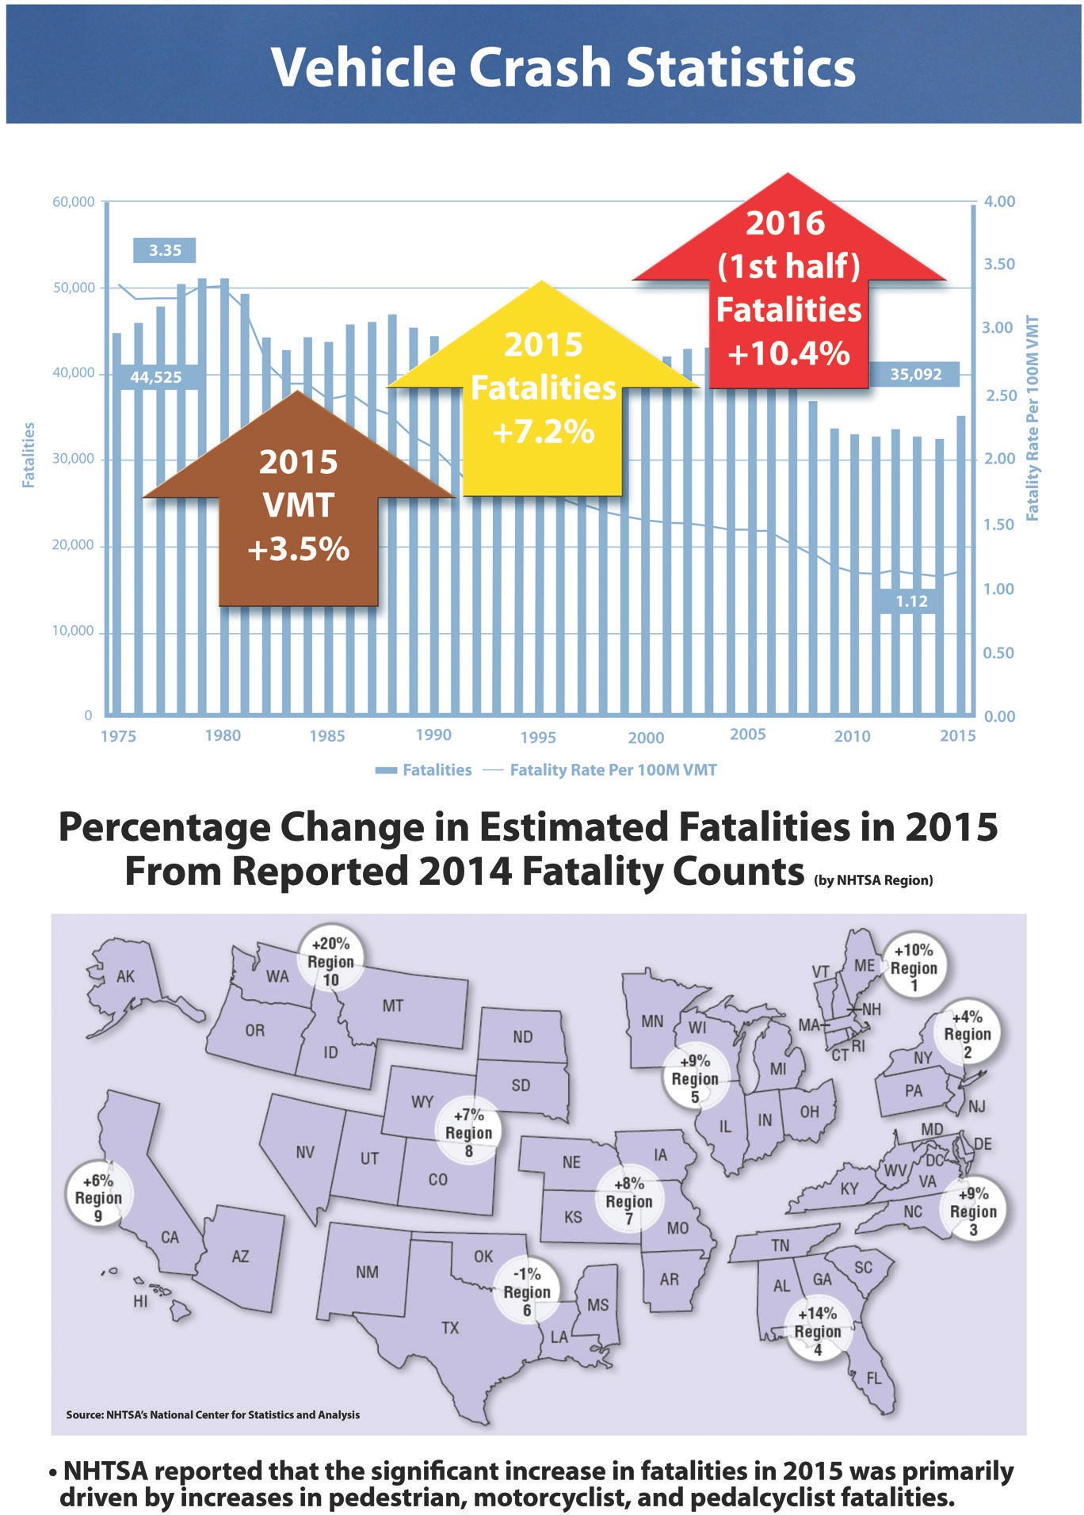

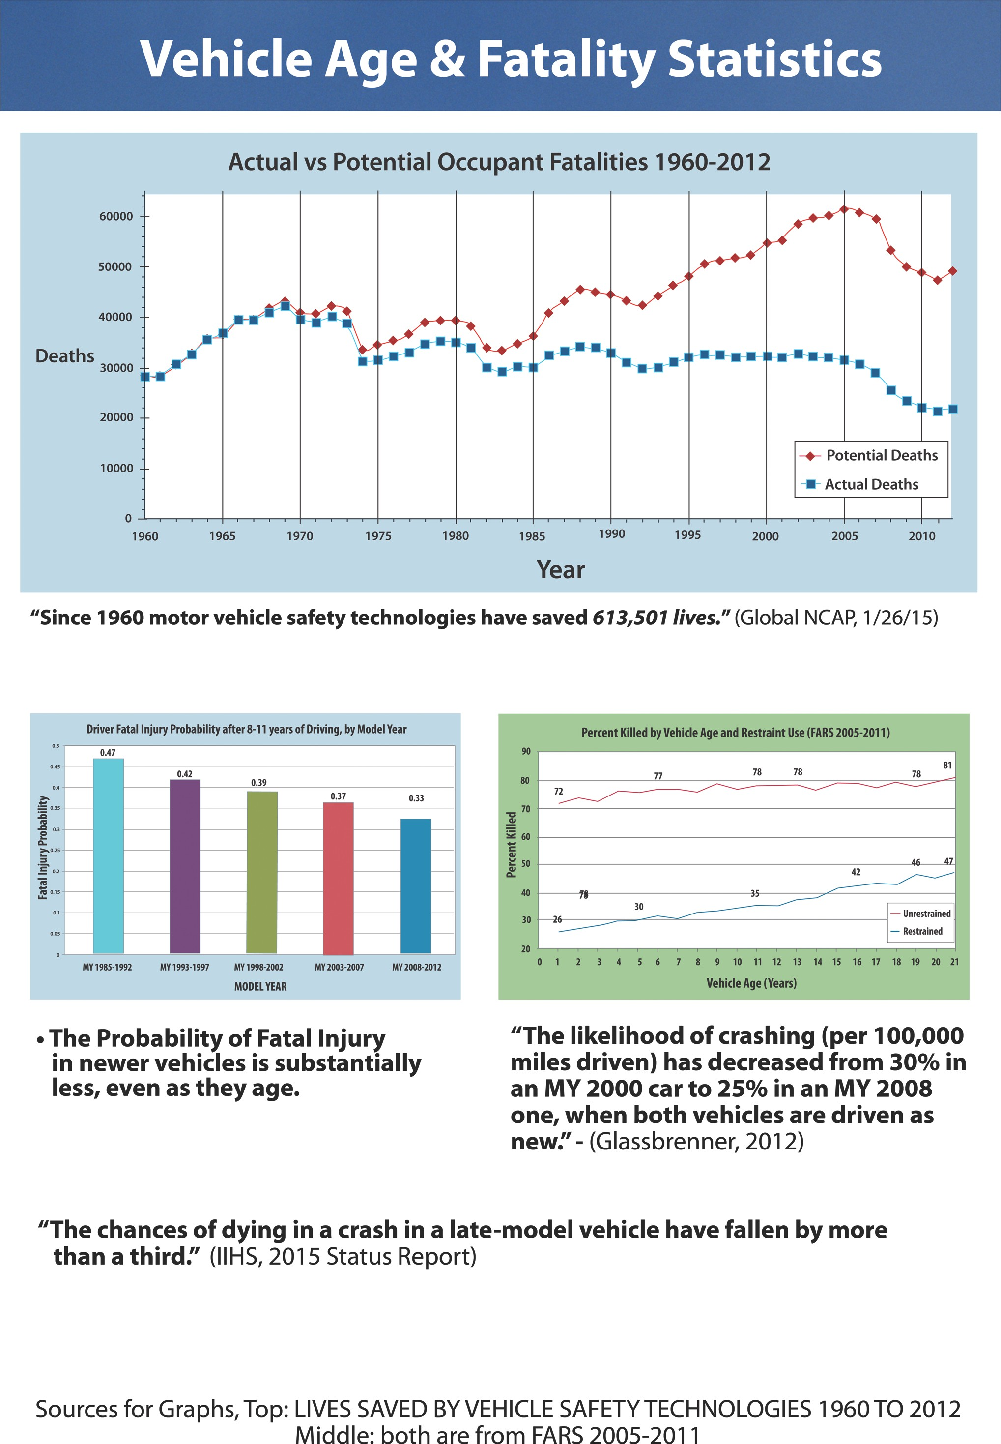

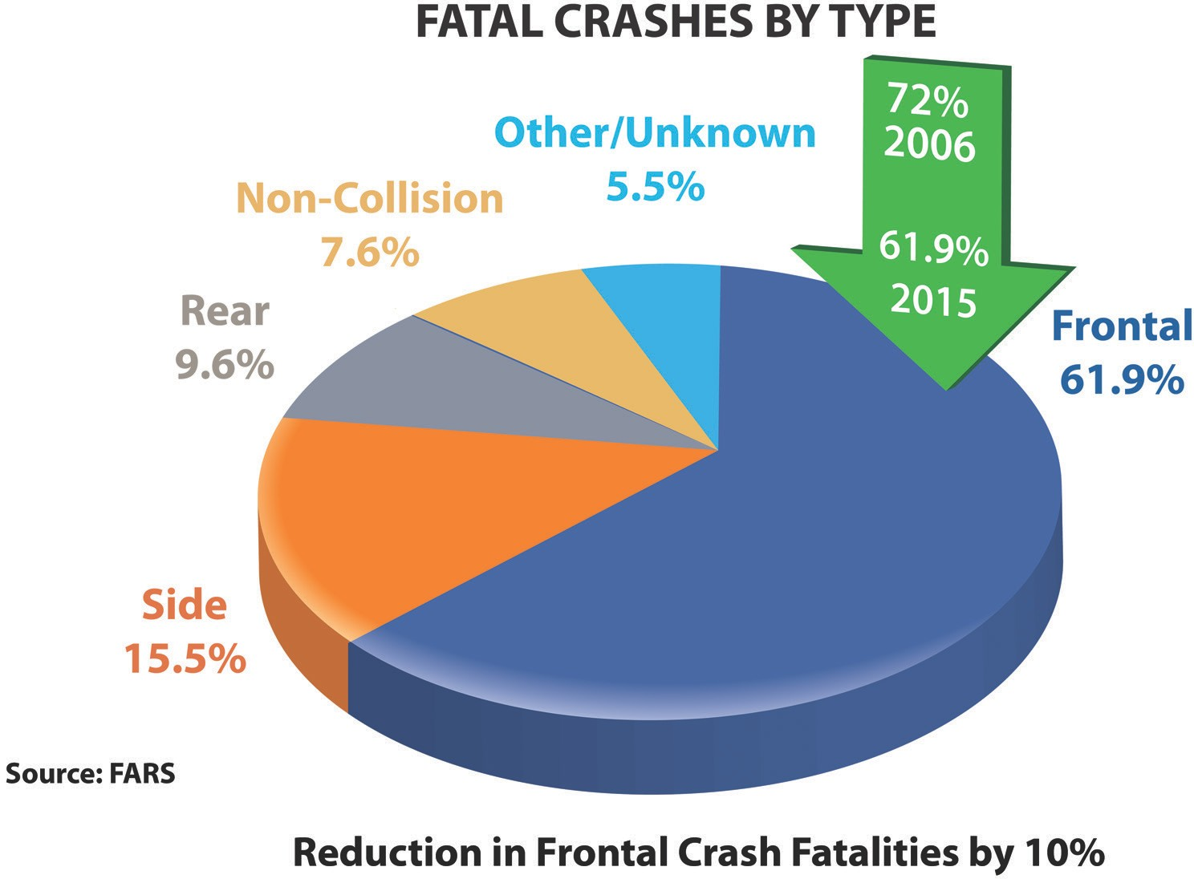
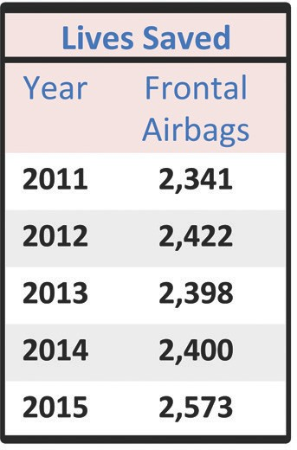

Proposed New US-NCAP Rating

Current NCAP
Proposed New NCAP
Weighted Sum

Overall rating
1 to 5 stars '

Crashworthiness
(Weight TBD)
/
"
Crash­ worthiness

Pedestrian
Protection

Crash Avoidance
5 star rating

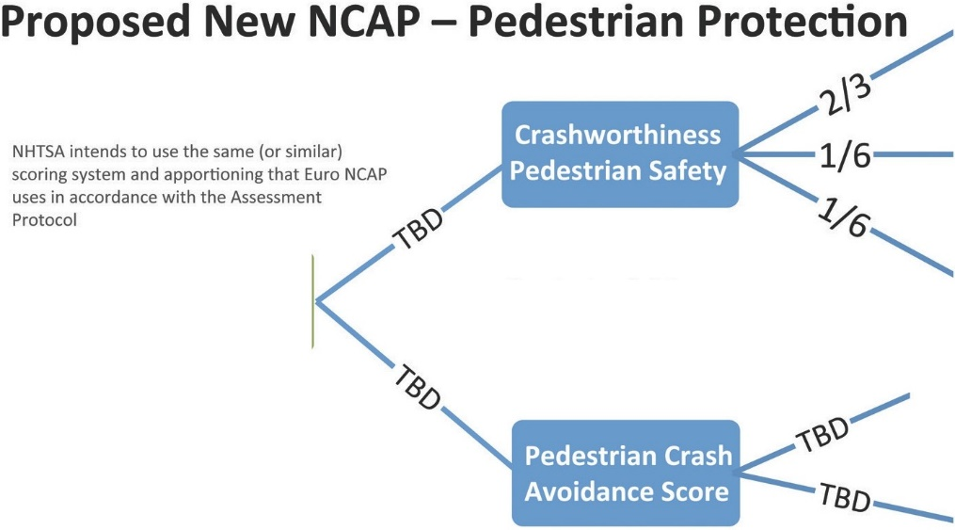
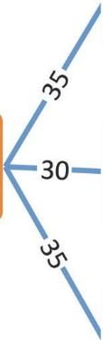
Head form tests

Upper leg form

Pedestrian Protection

Stan dard -> Full Score Optional -> Half Score Not Available/Fail ->Zero
Lower leg form

Pedestrian Automatic Emergency Braking

Rear Automatic Braking

Proposed New NCAP - Crash Avoidance llmll
----

Forward Collision
------
111122--
---- -

Crash
Avoidance

Visibility
<-:6:1s- -
Lower Beam Head Lighting
zu..1;;1;;.;••;;;1;;•;;.;.;.;;;.+11+

Table 11. Cras h Avoidance Rating Scale
CA Point Total CA Rating

----:_,iffiffi@ii•,ii,E1&ti•Ei,,ID
<CC - -,.
Other
Driver Awareness/
Mit\dl
 | 1-19  20-39  40-59 | I star  - star  - star
 | 60-79 | 4 star
 | 80-100 | 5 star

20-

4 O omot ive Safety Council

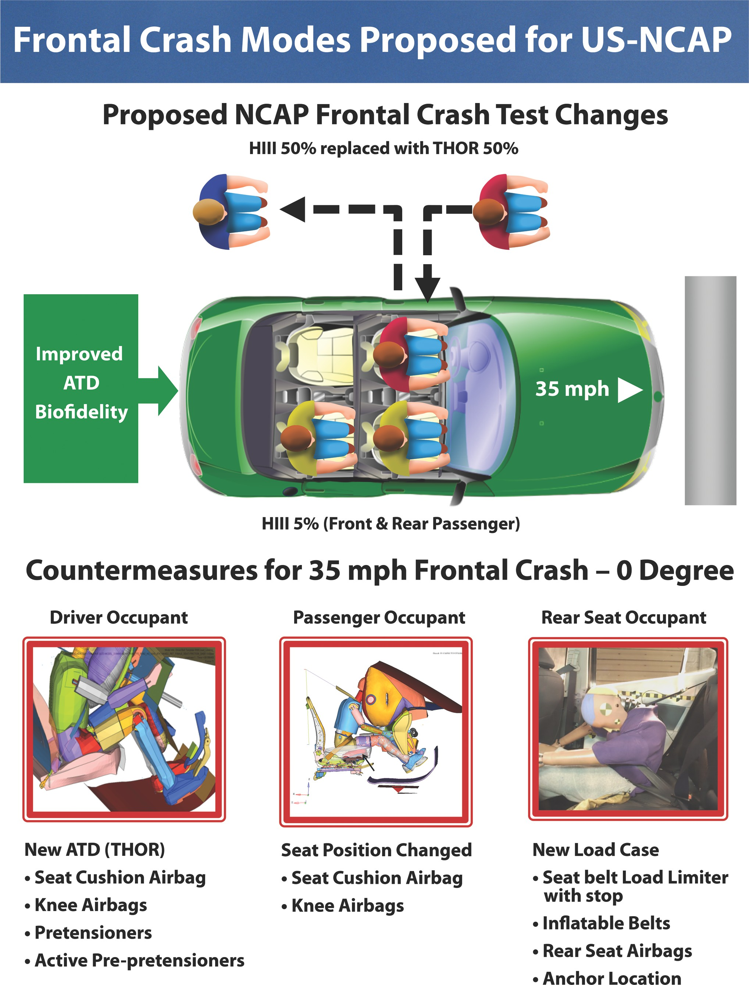

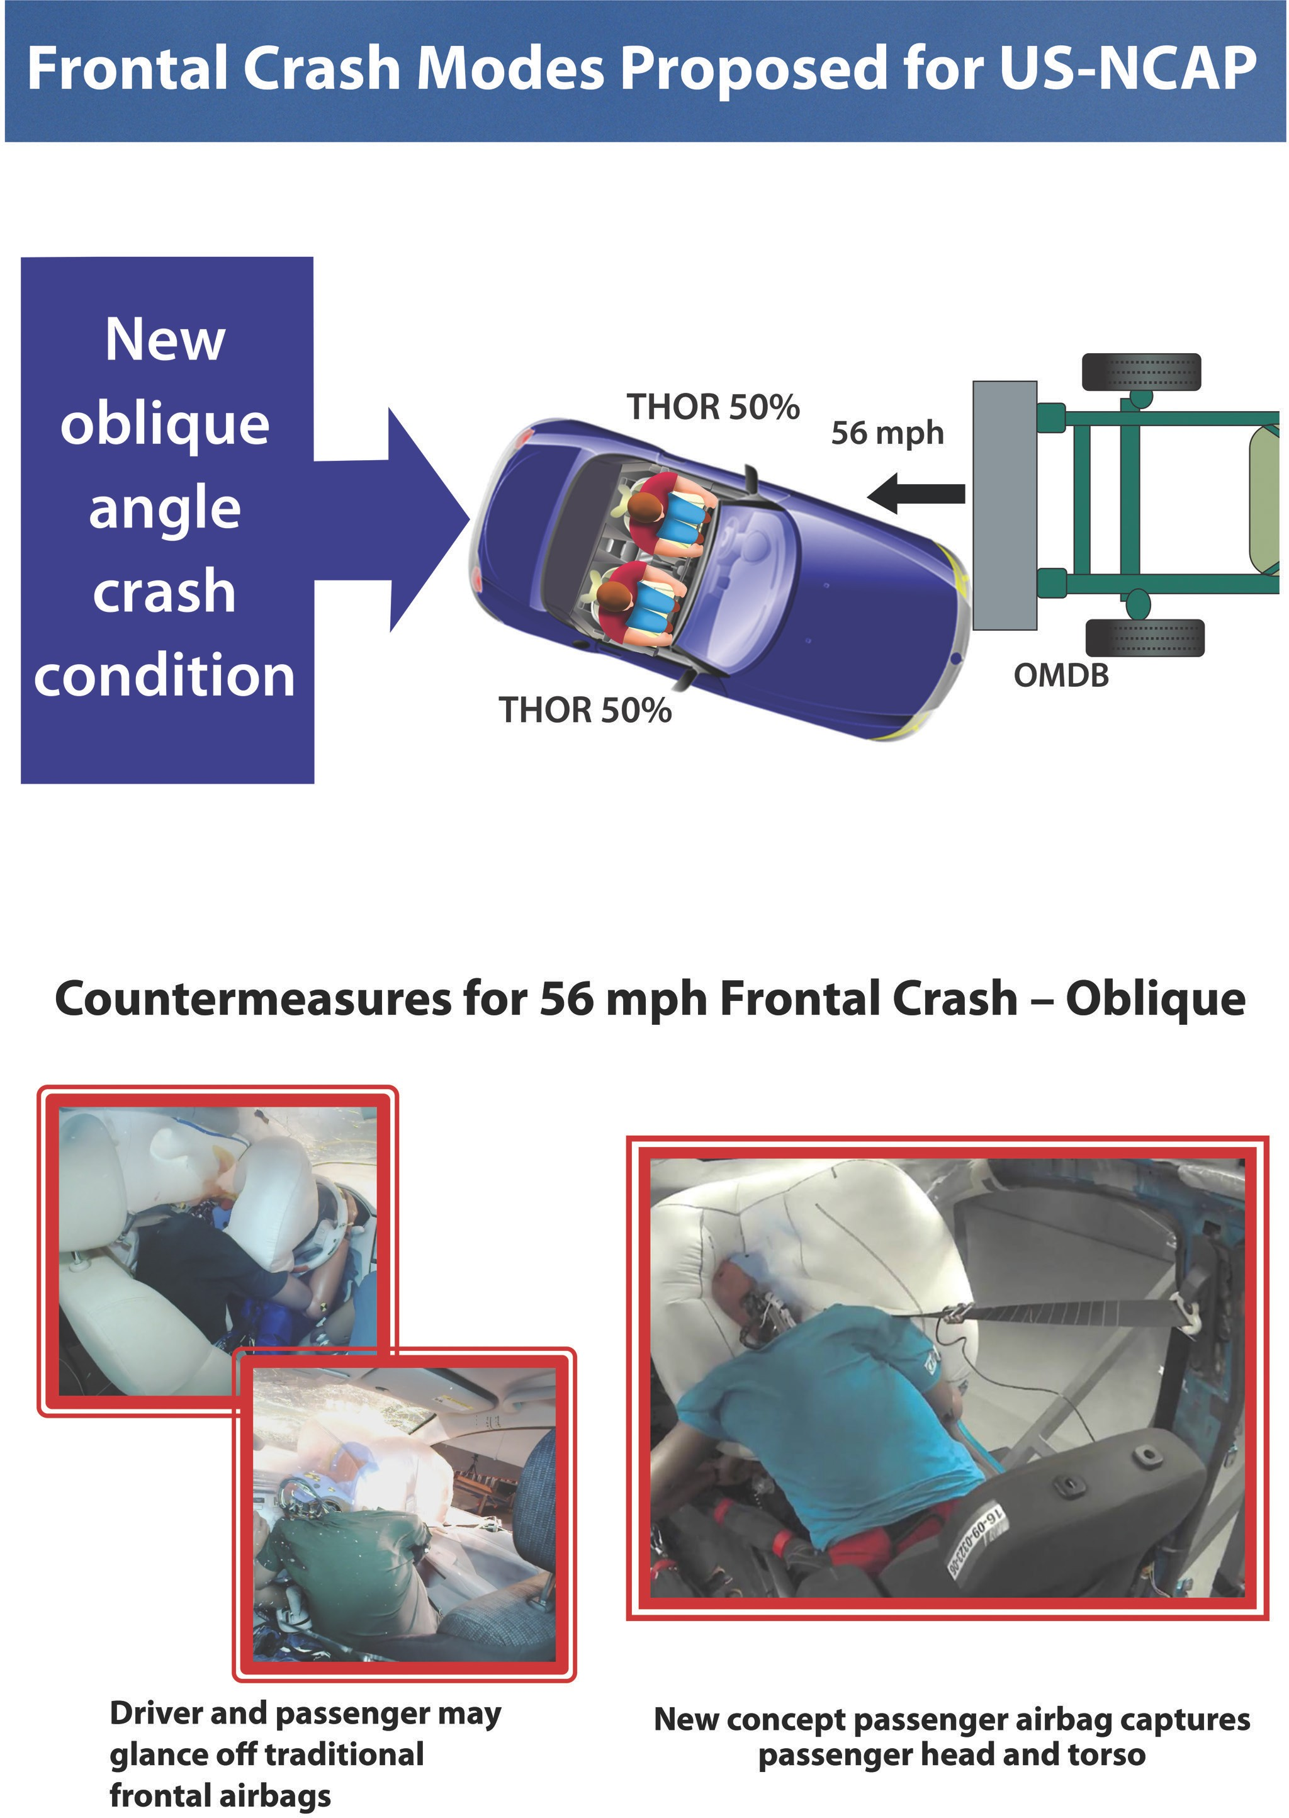

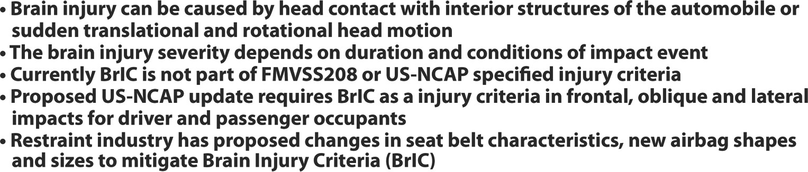
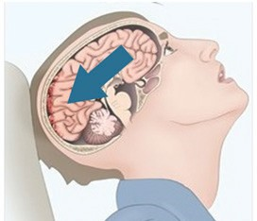
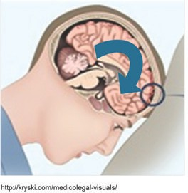

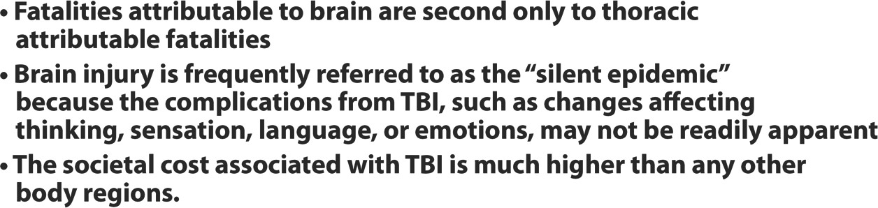
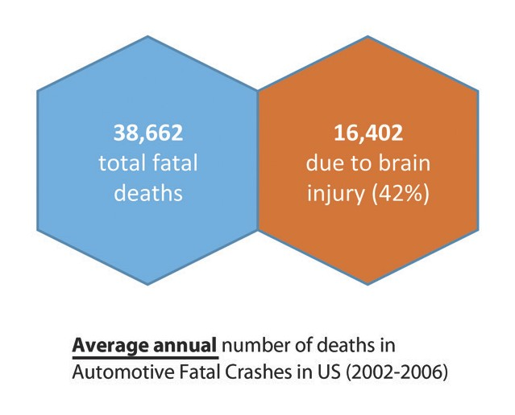

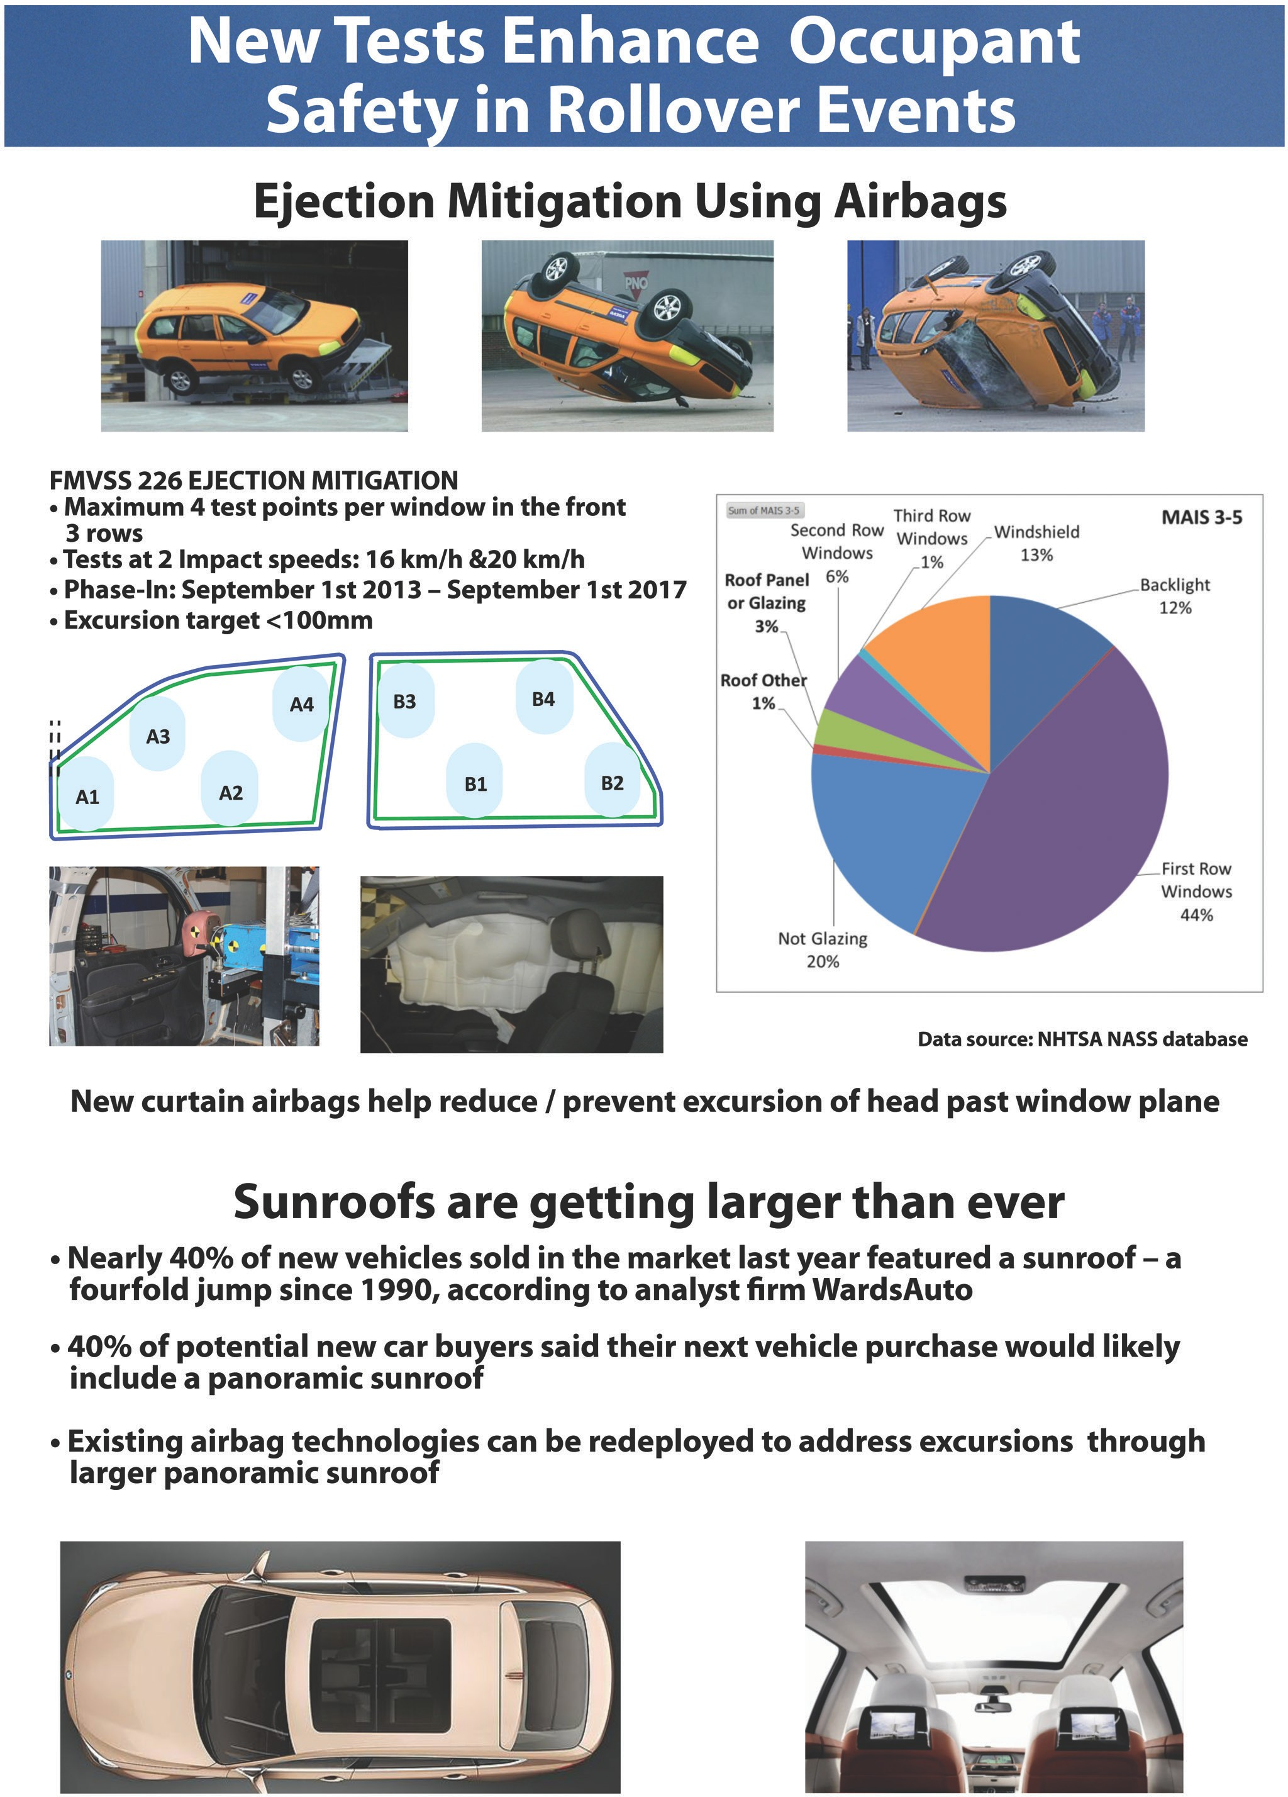

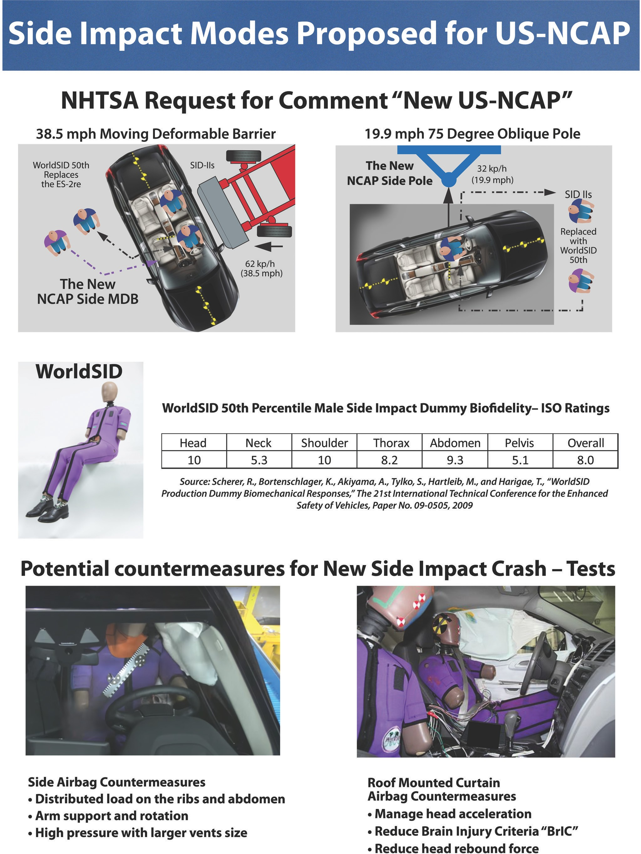

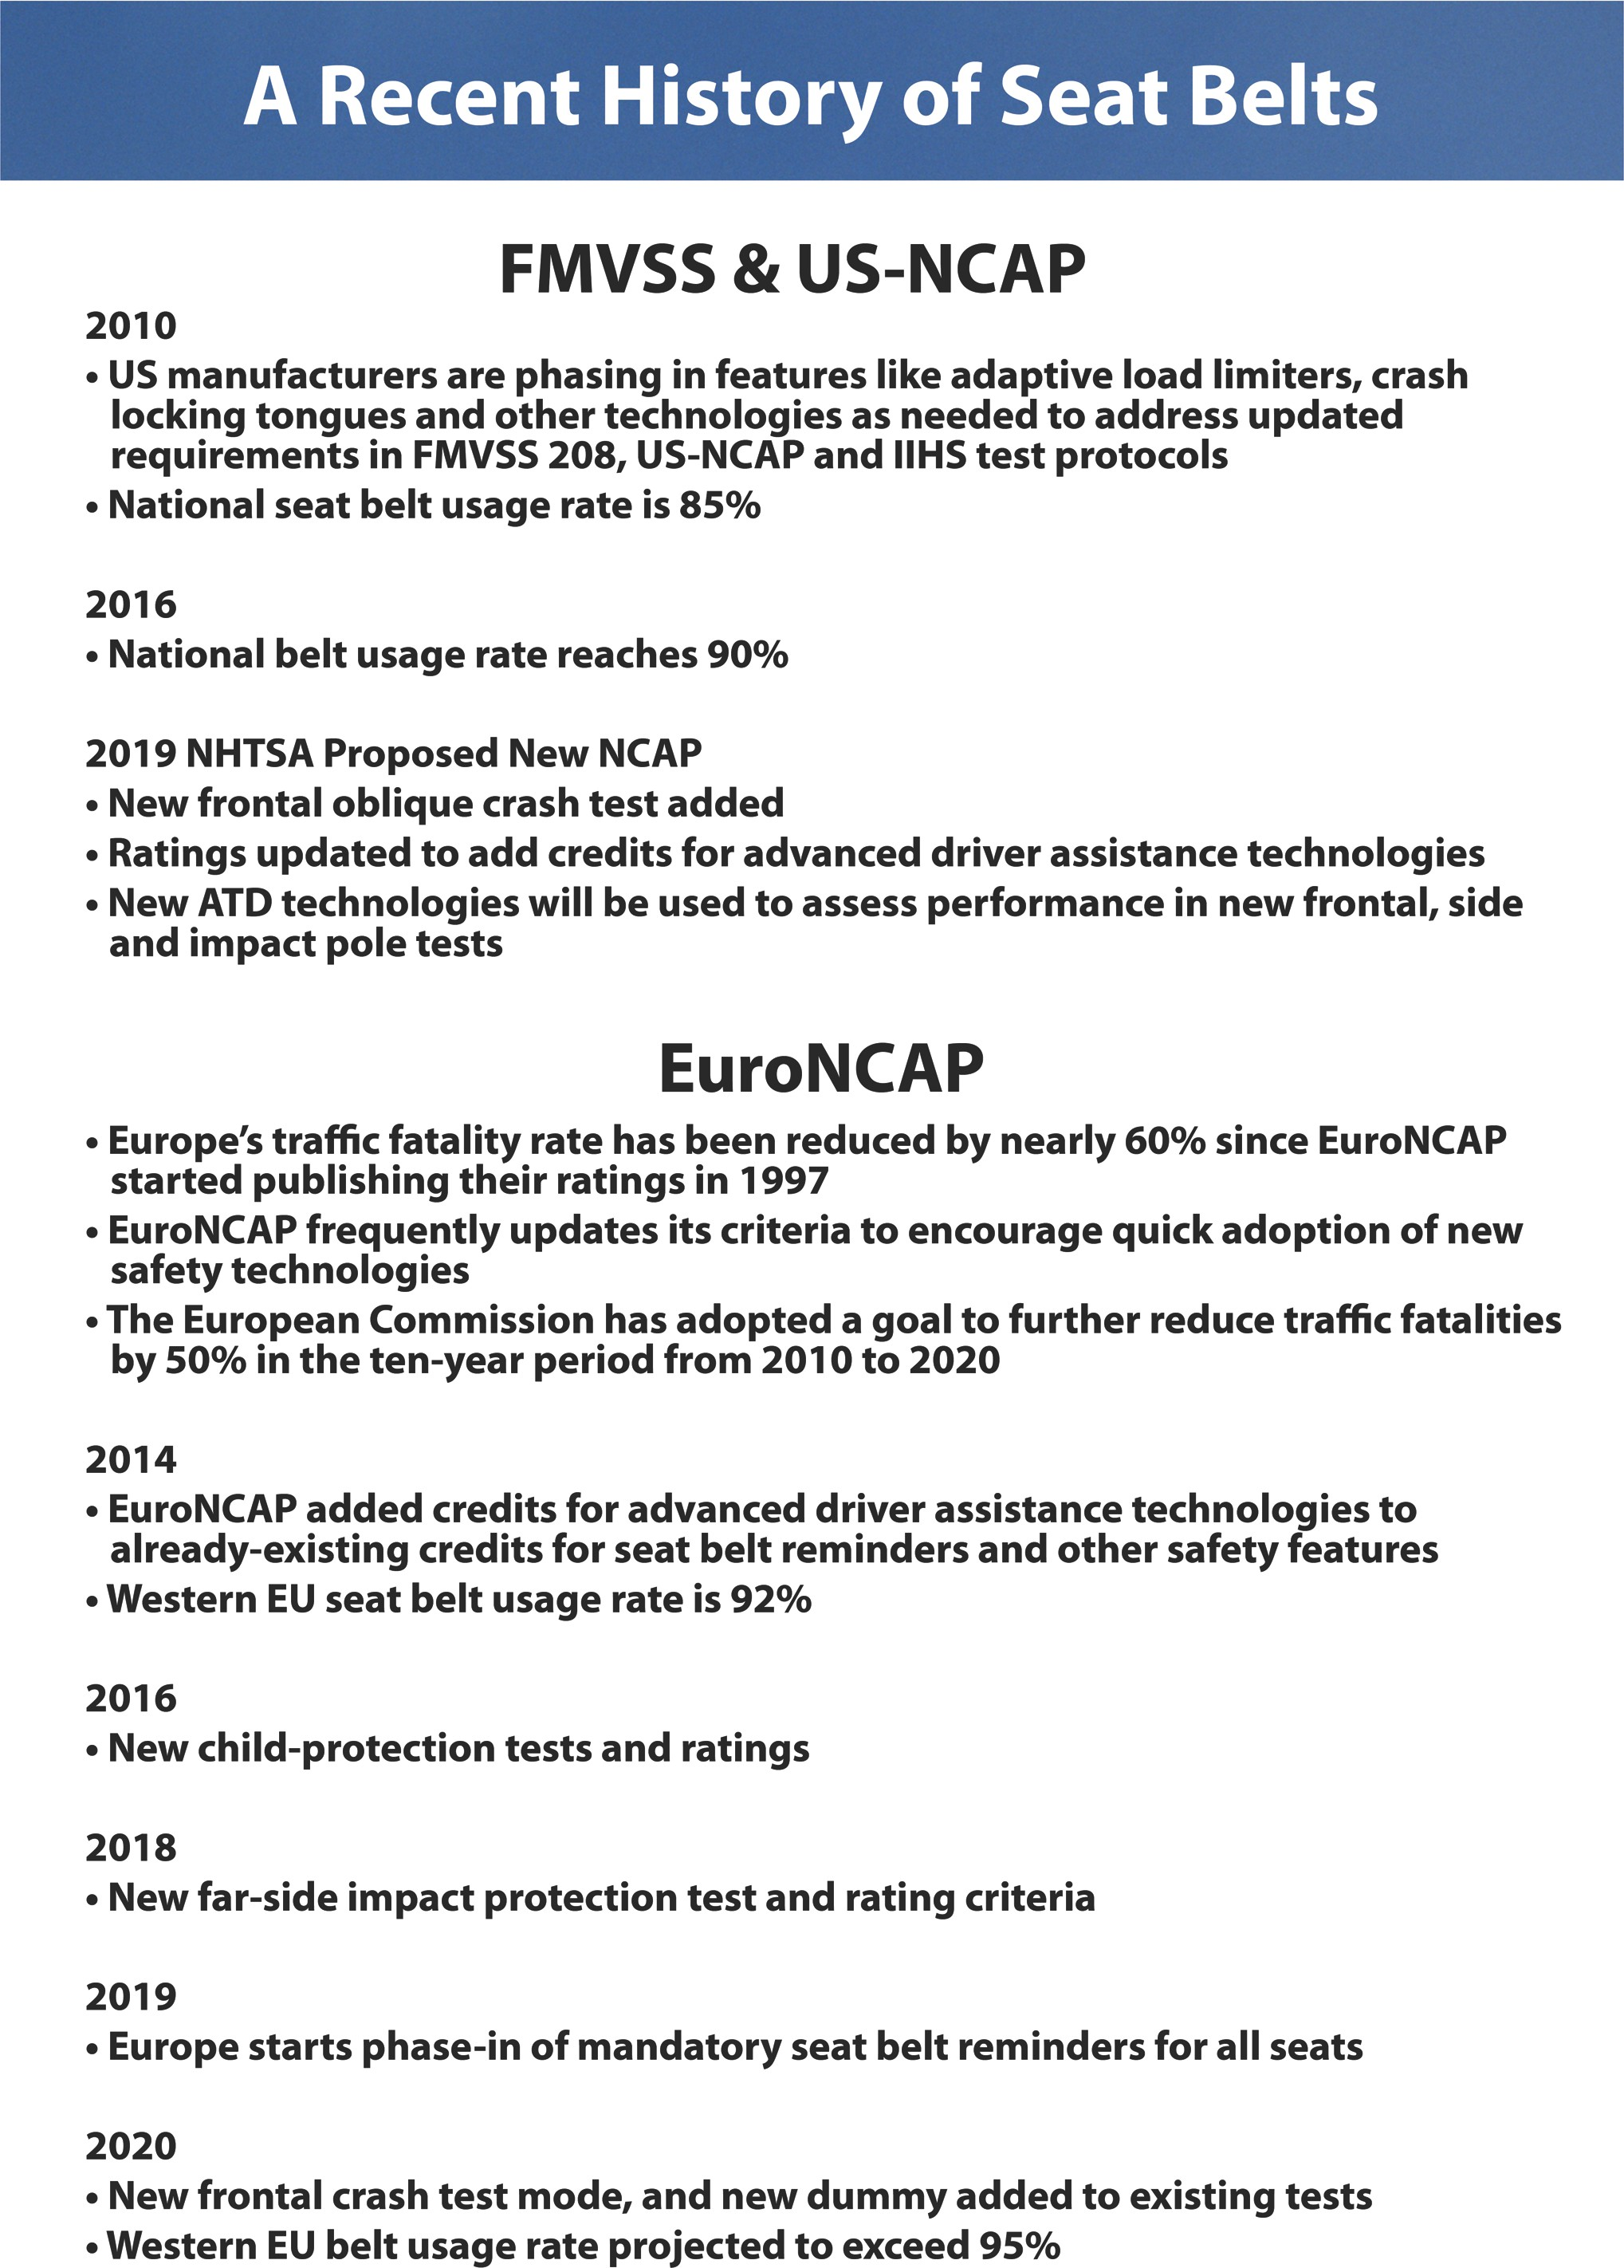

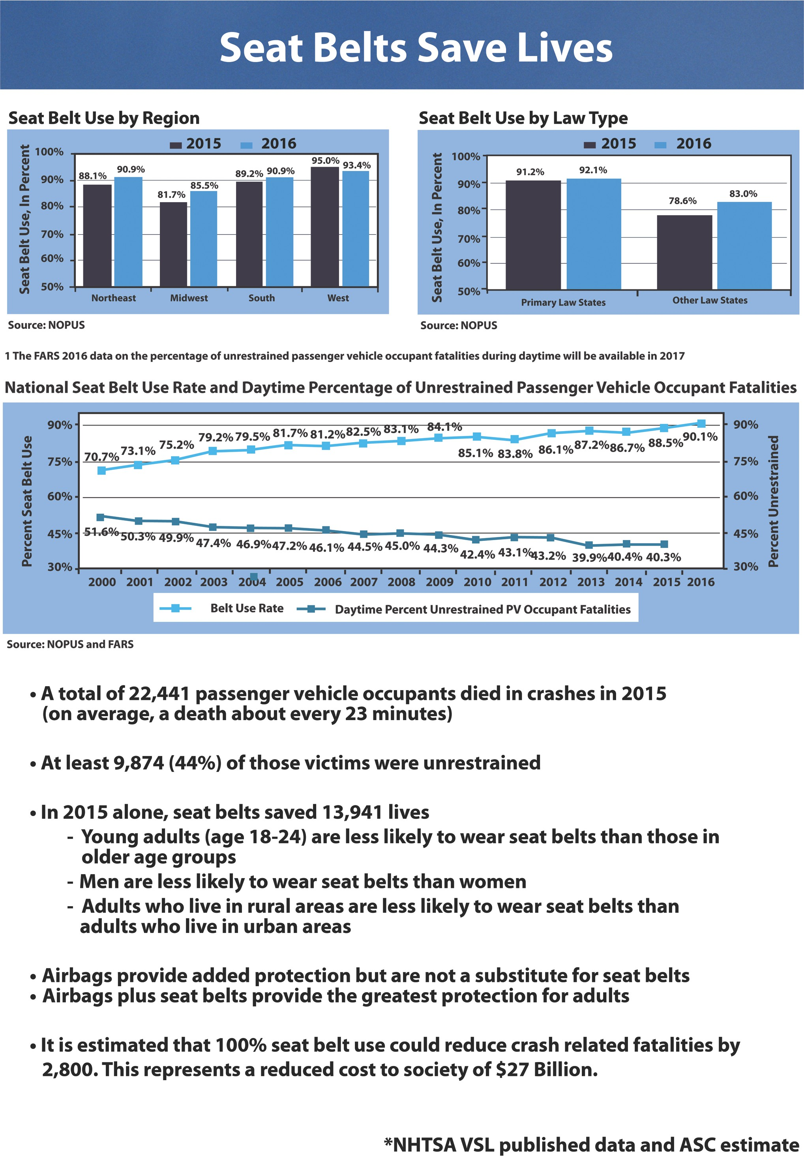

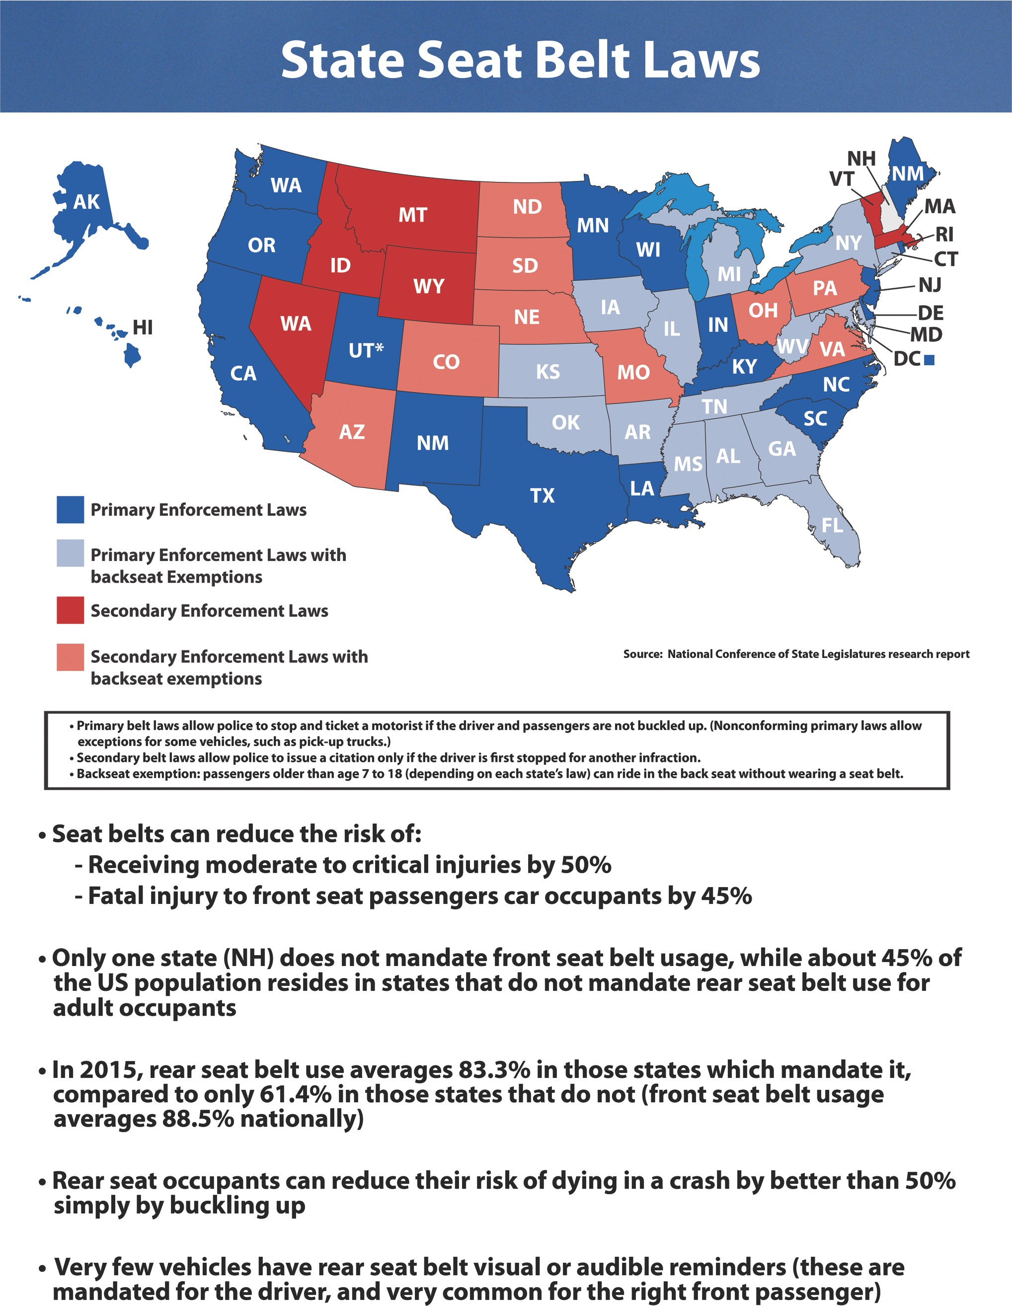

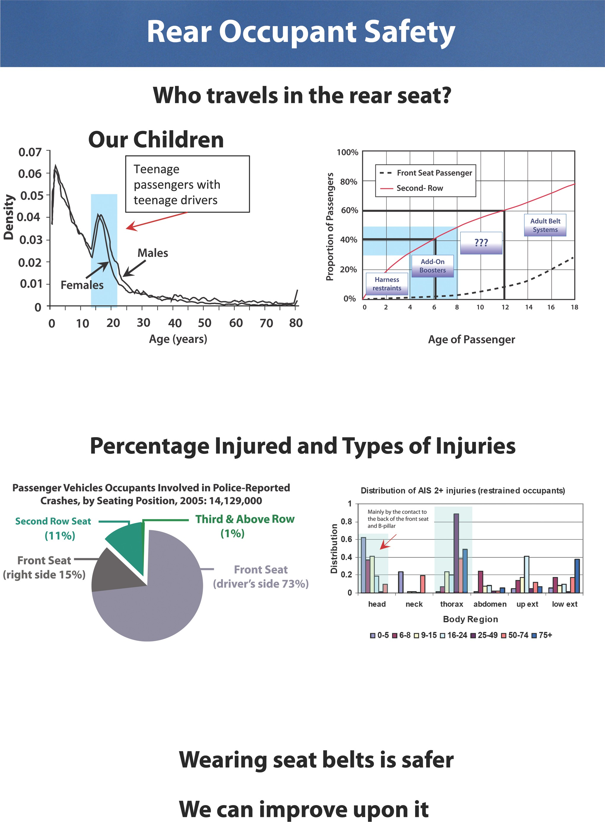

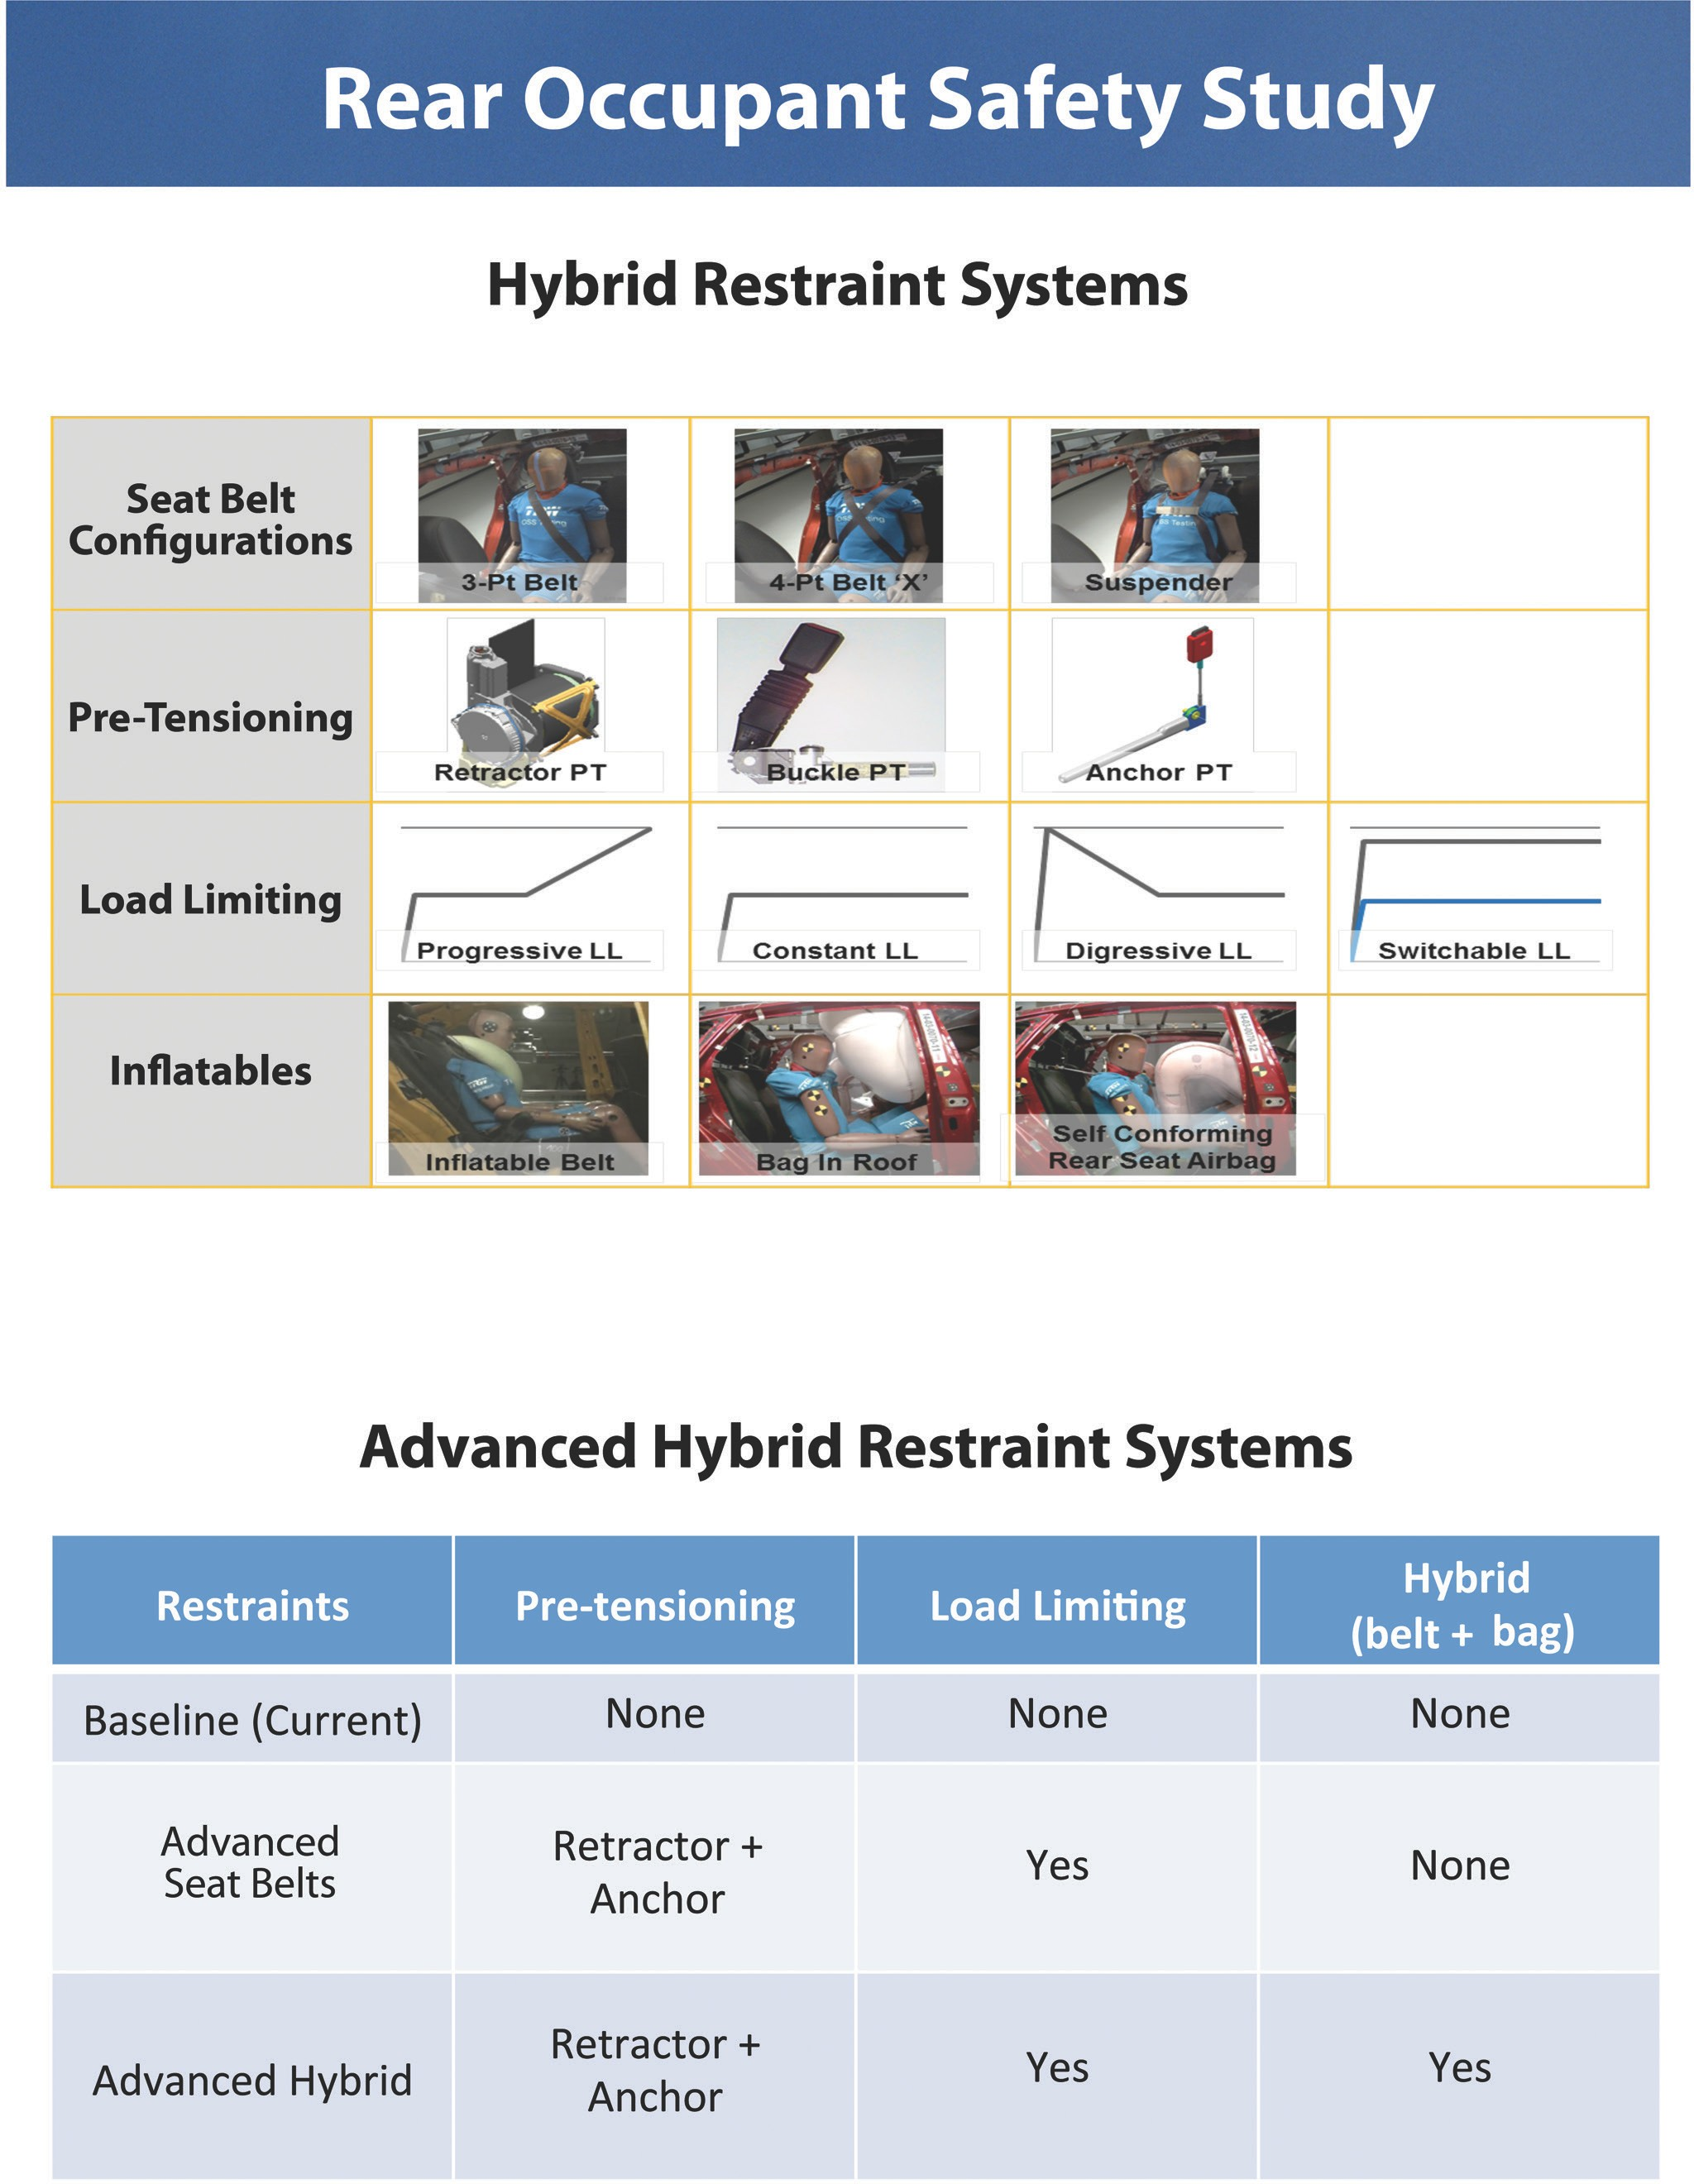

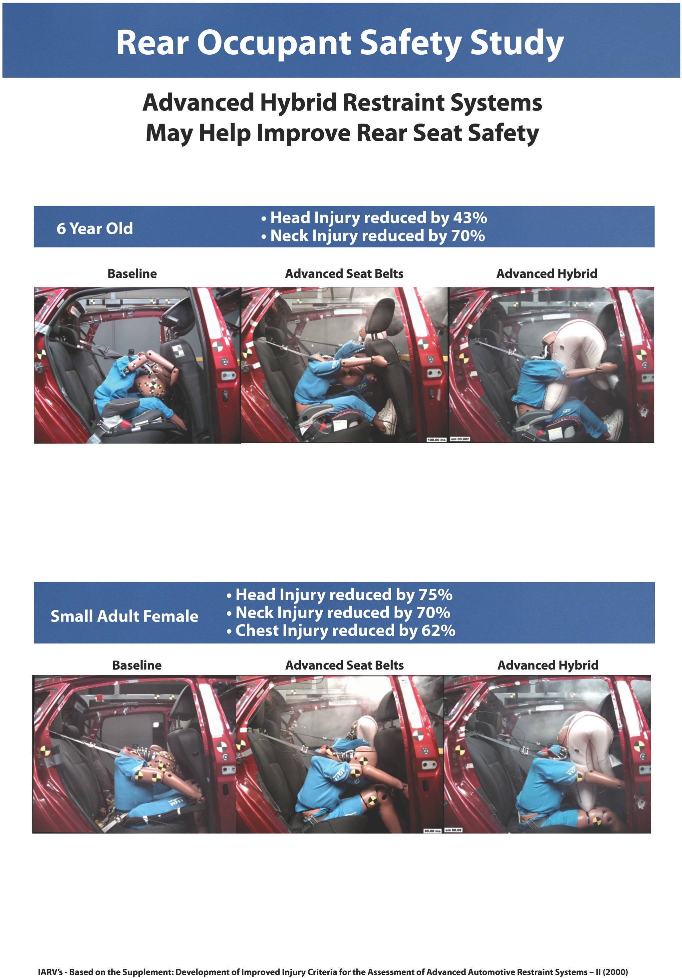

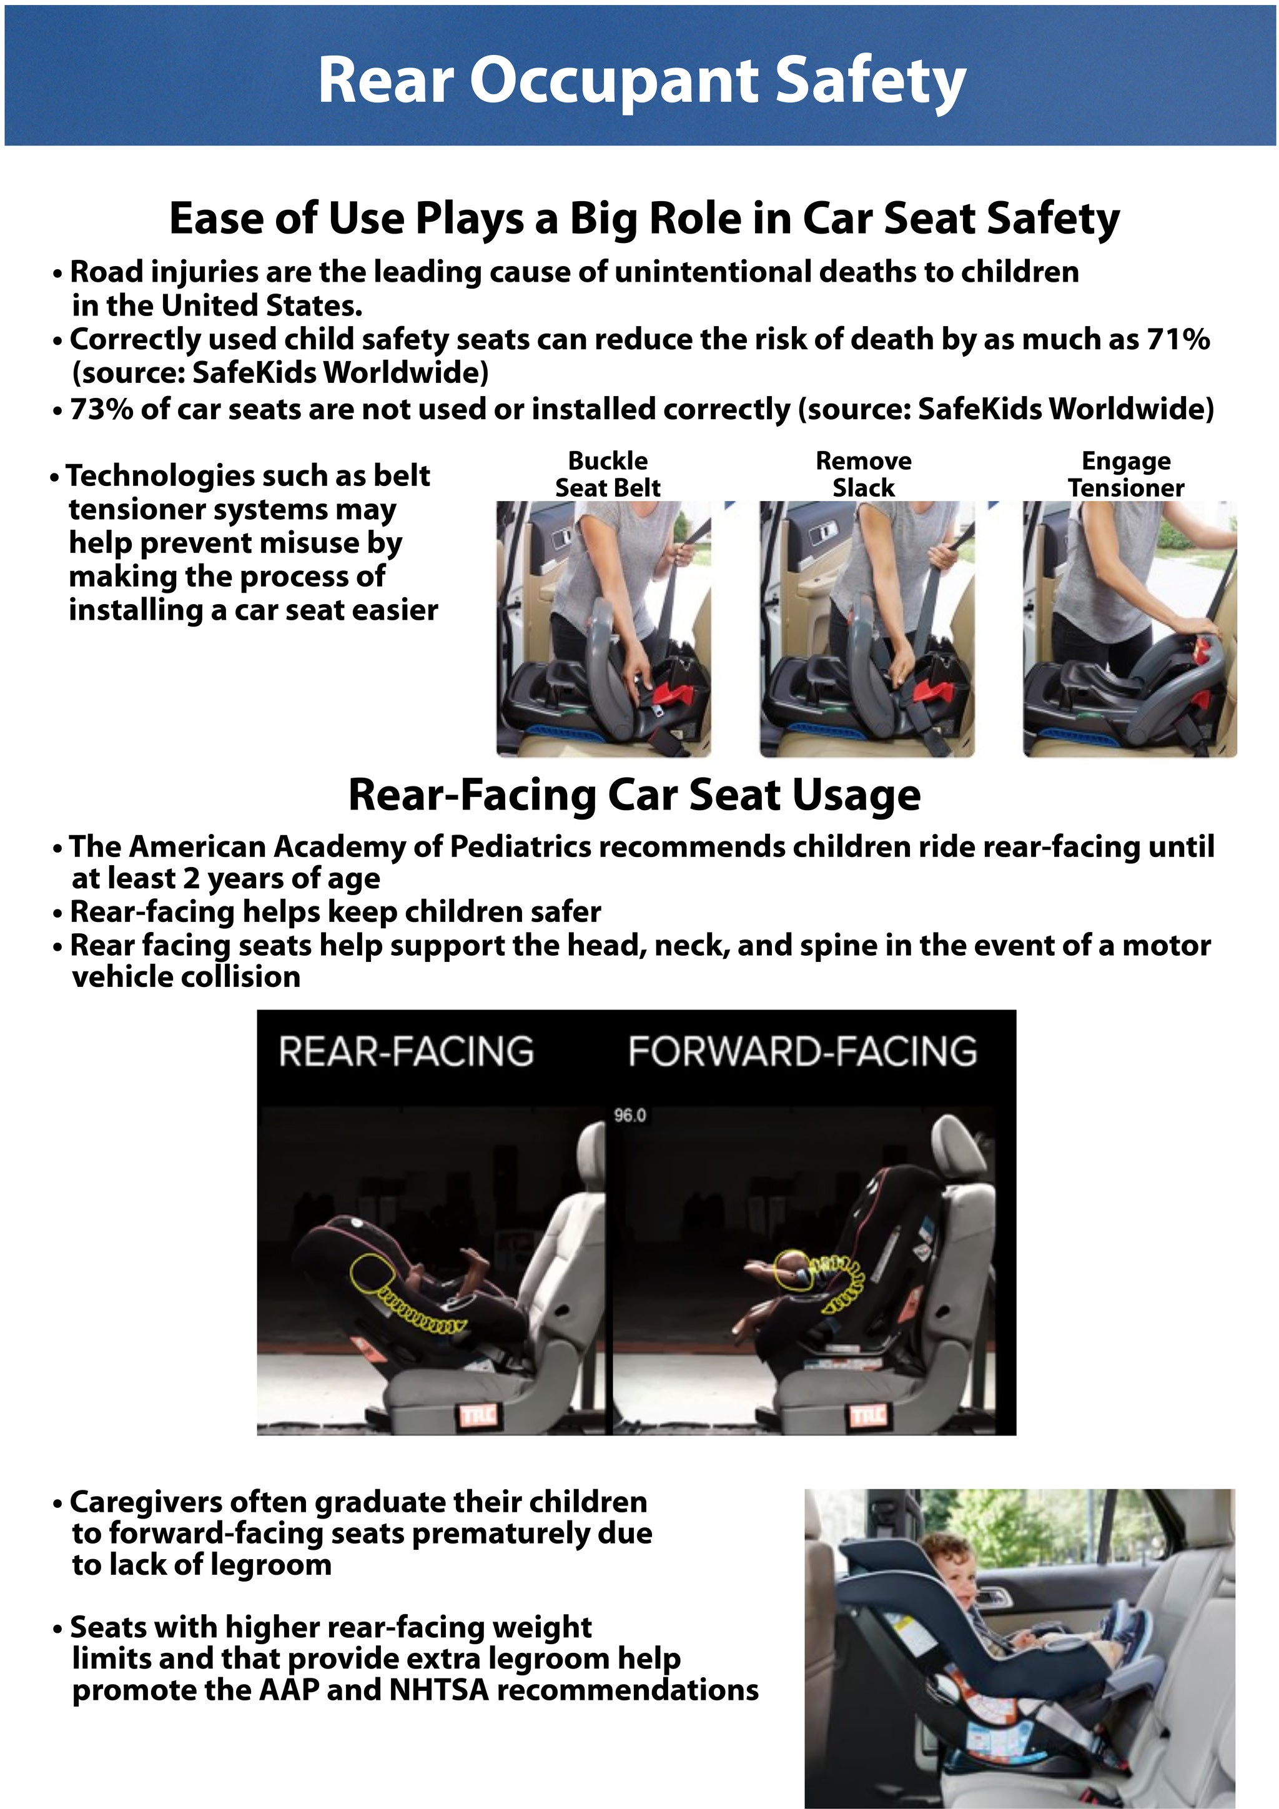

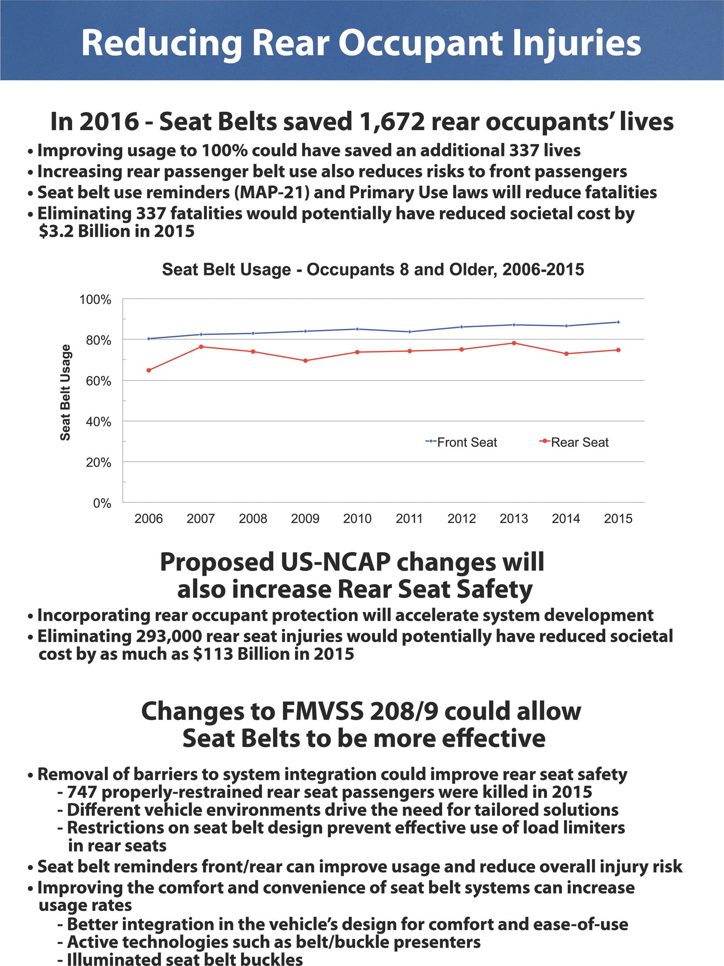

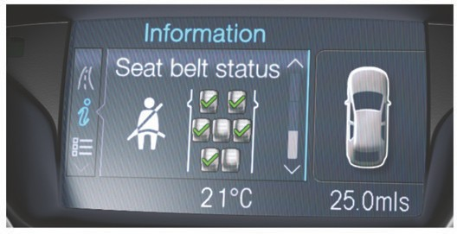
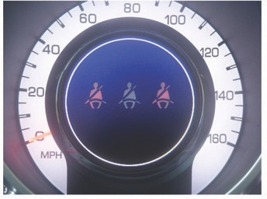

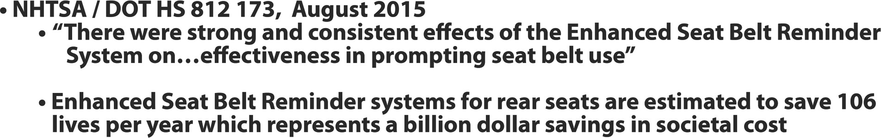

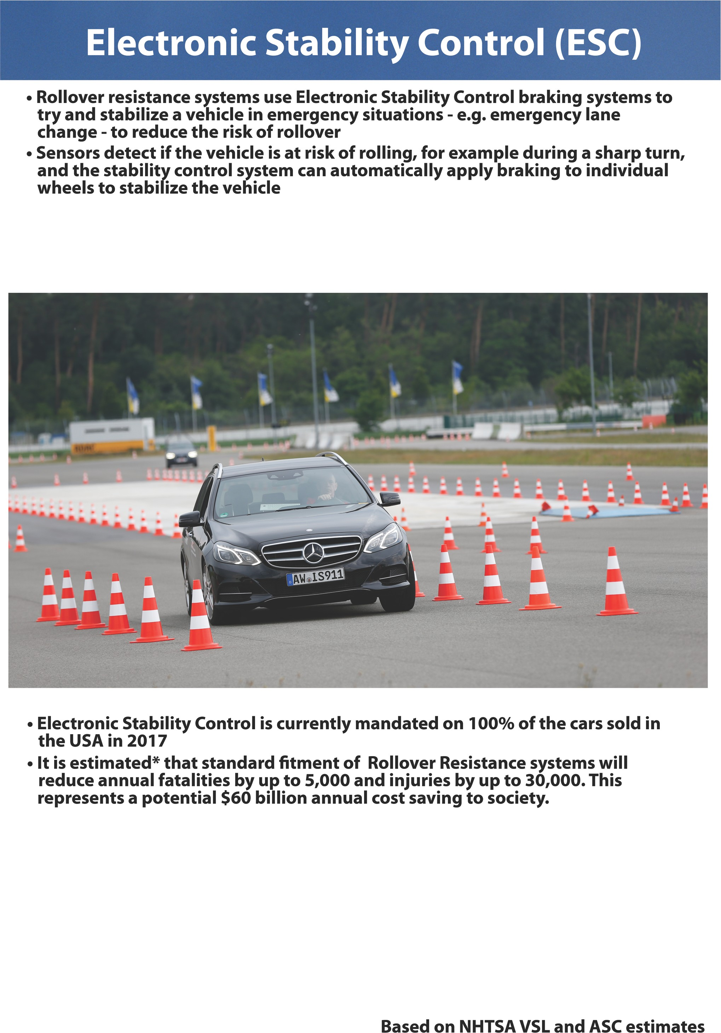

- FCW Systems use radar, laser or object detection cameras as sensors
- Measure relative speed and distance to objects ahead of the vehicle, and look for reducing time gaps and distances to vehicles / objects ahead
- When the system detects a potential collision, it can:
  - Warn the driver using audio, visual or haptic (e.g. vibration) alarms
  - Prepare the vehicle’s brakes for a faster response when the driver presses the brake pedal

- These technologies are currently available as options or standard fit on 18% of the cards sold in the USA in 2017
- It is estimated that 100% inclusion of this technology could reduce annual fatalities by up to 35 and injuries by up to 55,000. This represents a potential $22 Billion annual cost saving to society.

Based on NHTSA and NCAP data

- AEB equipped vehicles with Crash Imminent Braking and Dynamic Brake Support will:
  - Alert drivers of a dangerous situation using audio, visual or haptic alarms (Forward Collision Warning)
  - Automatically apply the vehicle brakes when an imminent collision is detected (Crash Imminent Braking)
-Automatically increase braking if driver does initiate braking but with insufficient amount to avoid a collision (Dynamic Brake Support)

- Standard equipment on ~ 6% 2016 vehicle models
- Optional on ~ 51% of all 2016 vehicle models
- Installed on ~ 16% of all 2016 vehicles sold
- U.S. DOT and IIHS announced the commitment of 20 manufacturers to make this technology standard on all cars and trucks by 2022
- It is estimated that 100% inclusion of this technology could reduce fatalities by up to ~ 108 and injuries by up to ~ 150,000 annually. This represents a potential $58 Billion annual cost saving to society.

Based on NHTSA VSL and ASC estimates

- Use forward-looking camera or other sensors to detect lane markings and identify when the driver is unintentionally leaving the lane
  - Lane Departure Warning provides audible, visual and/ or haptic (e.g. vibration) alerts to the driver
  - Lane Keeping Assist uses the steering system to help the driver keep safely within the lane
  - System does not activate if driver uses turn signals to confirm planned lane change or exit - increases use of turn signals in highway driving

- This technology is currently available as option of standard fit on ~ 12% of the cars sold in the USA in 2017
- It is estimated* that 100% inclusion or Lane Departure Prevention systems could reduce annual fatalities by up to ~ 7,500 and annual injuries by up to 37,000. This represents a potential $86 billion annual cost saving to society.

Based on NHTSA VSL and ASC estimates

- BSD equipped vehicles can:
  - Detection of one or more vehicles in either adjacent lane that may not be seen by the driver
  - Alert the driver to help facilitate safe lane changes with either audio, visual or haptic alarms
  - Be enhanced to include Active Lane Keeping Support

- BSD was installed on ~ 33% of all new vehicles sold in the US in 2016
- It is estimated that 100% inclusion of this technology could reduce annual fatalities by up to
~ 393 and injuries by up to ~ 20,000. This represents a potential $11.5 Billion annual cost saving to society.

Based on NHTSA VSL and ASC estimates

- FMVSS111 Rear Visibility requires rearview image directly behind the vehicle Sept 2018
  - Installed on ~ 87% of all new vehicles sold in the US in 2016
-Estimated to reduce annual fatalities by ~ 69 and injuries by ~ 5,000. This represents an estimated
$2.6 Billion cost saving to society.

- Rear AEB enhanced systems detect objects behind vehicles that are difficult for the driver to see while backing up
  - Display the rear view on a static screen located in drivers view
  - Alerting the driver and automatically braking if necessary
- No specific studies exist, but simulations indicate if rear automatic emergency braking had 100% inclusion, fatalities could be incrementally reduced by ~ 189 and injuries by ~ 13,500 representing a potential $4.4 Billion annual cost saving to society above the current FMVSS111 rule.

Based on NHTSA VSL and ASC estimates

- RCTA equipped vehicles can:
  - Improve the safety of backing up in cross traffic situations not seen by Rear Object Camera systems
  - Increases the field of view to assist the driver backing out of a parking space or alley by alerting the driver
  - Be enhanced to include Rear Automatic Emergency Braking

- RCTA was installed on ~ 23% of all new vehicles sold in the US in 2016
- It is estimated that once camera with display only are standard equipment this could reduce annual fatalities by up to ~ 69 and injuries by up to ~ 5,000. This represents a potential $2.6 Billion annual cost saving to society.
- Making Automatic Braking and Rear Cross Traffic Alert standard on 100% of vehicle produced can reduce fatalities and injuries even further

Based on NHTSA VSL and ASC estimates

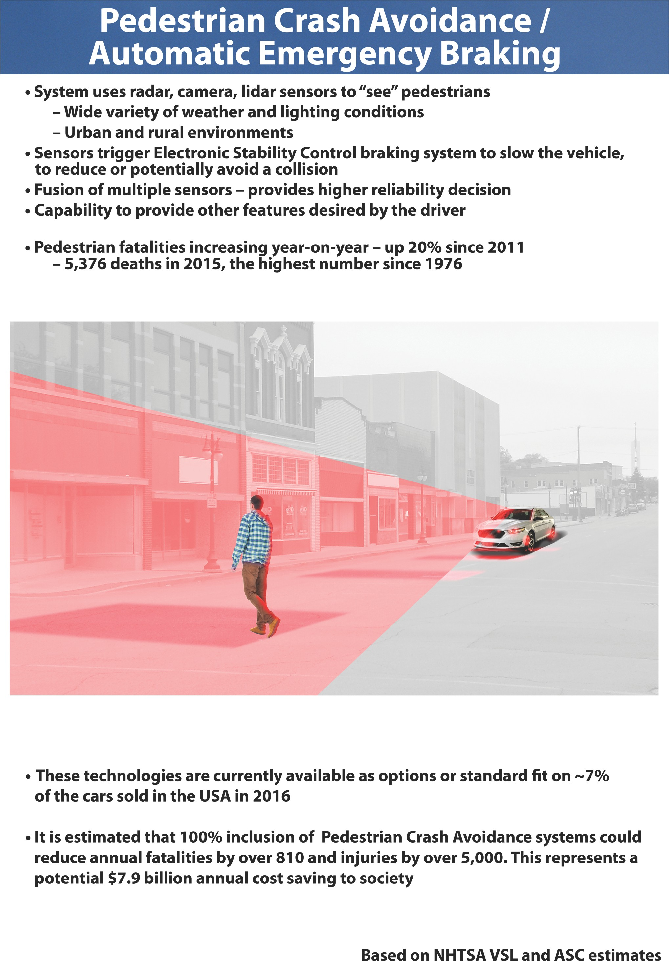

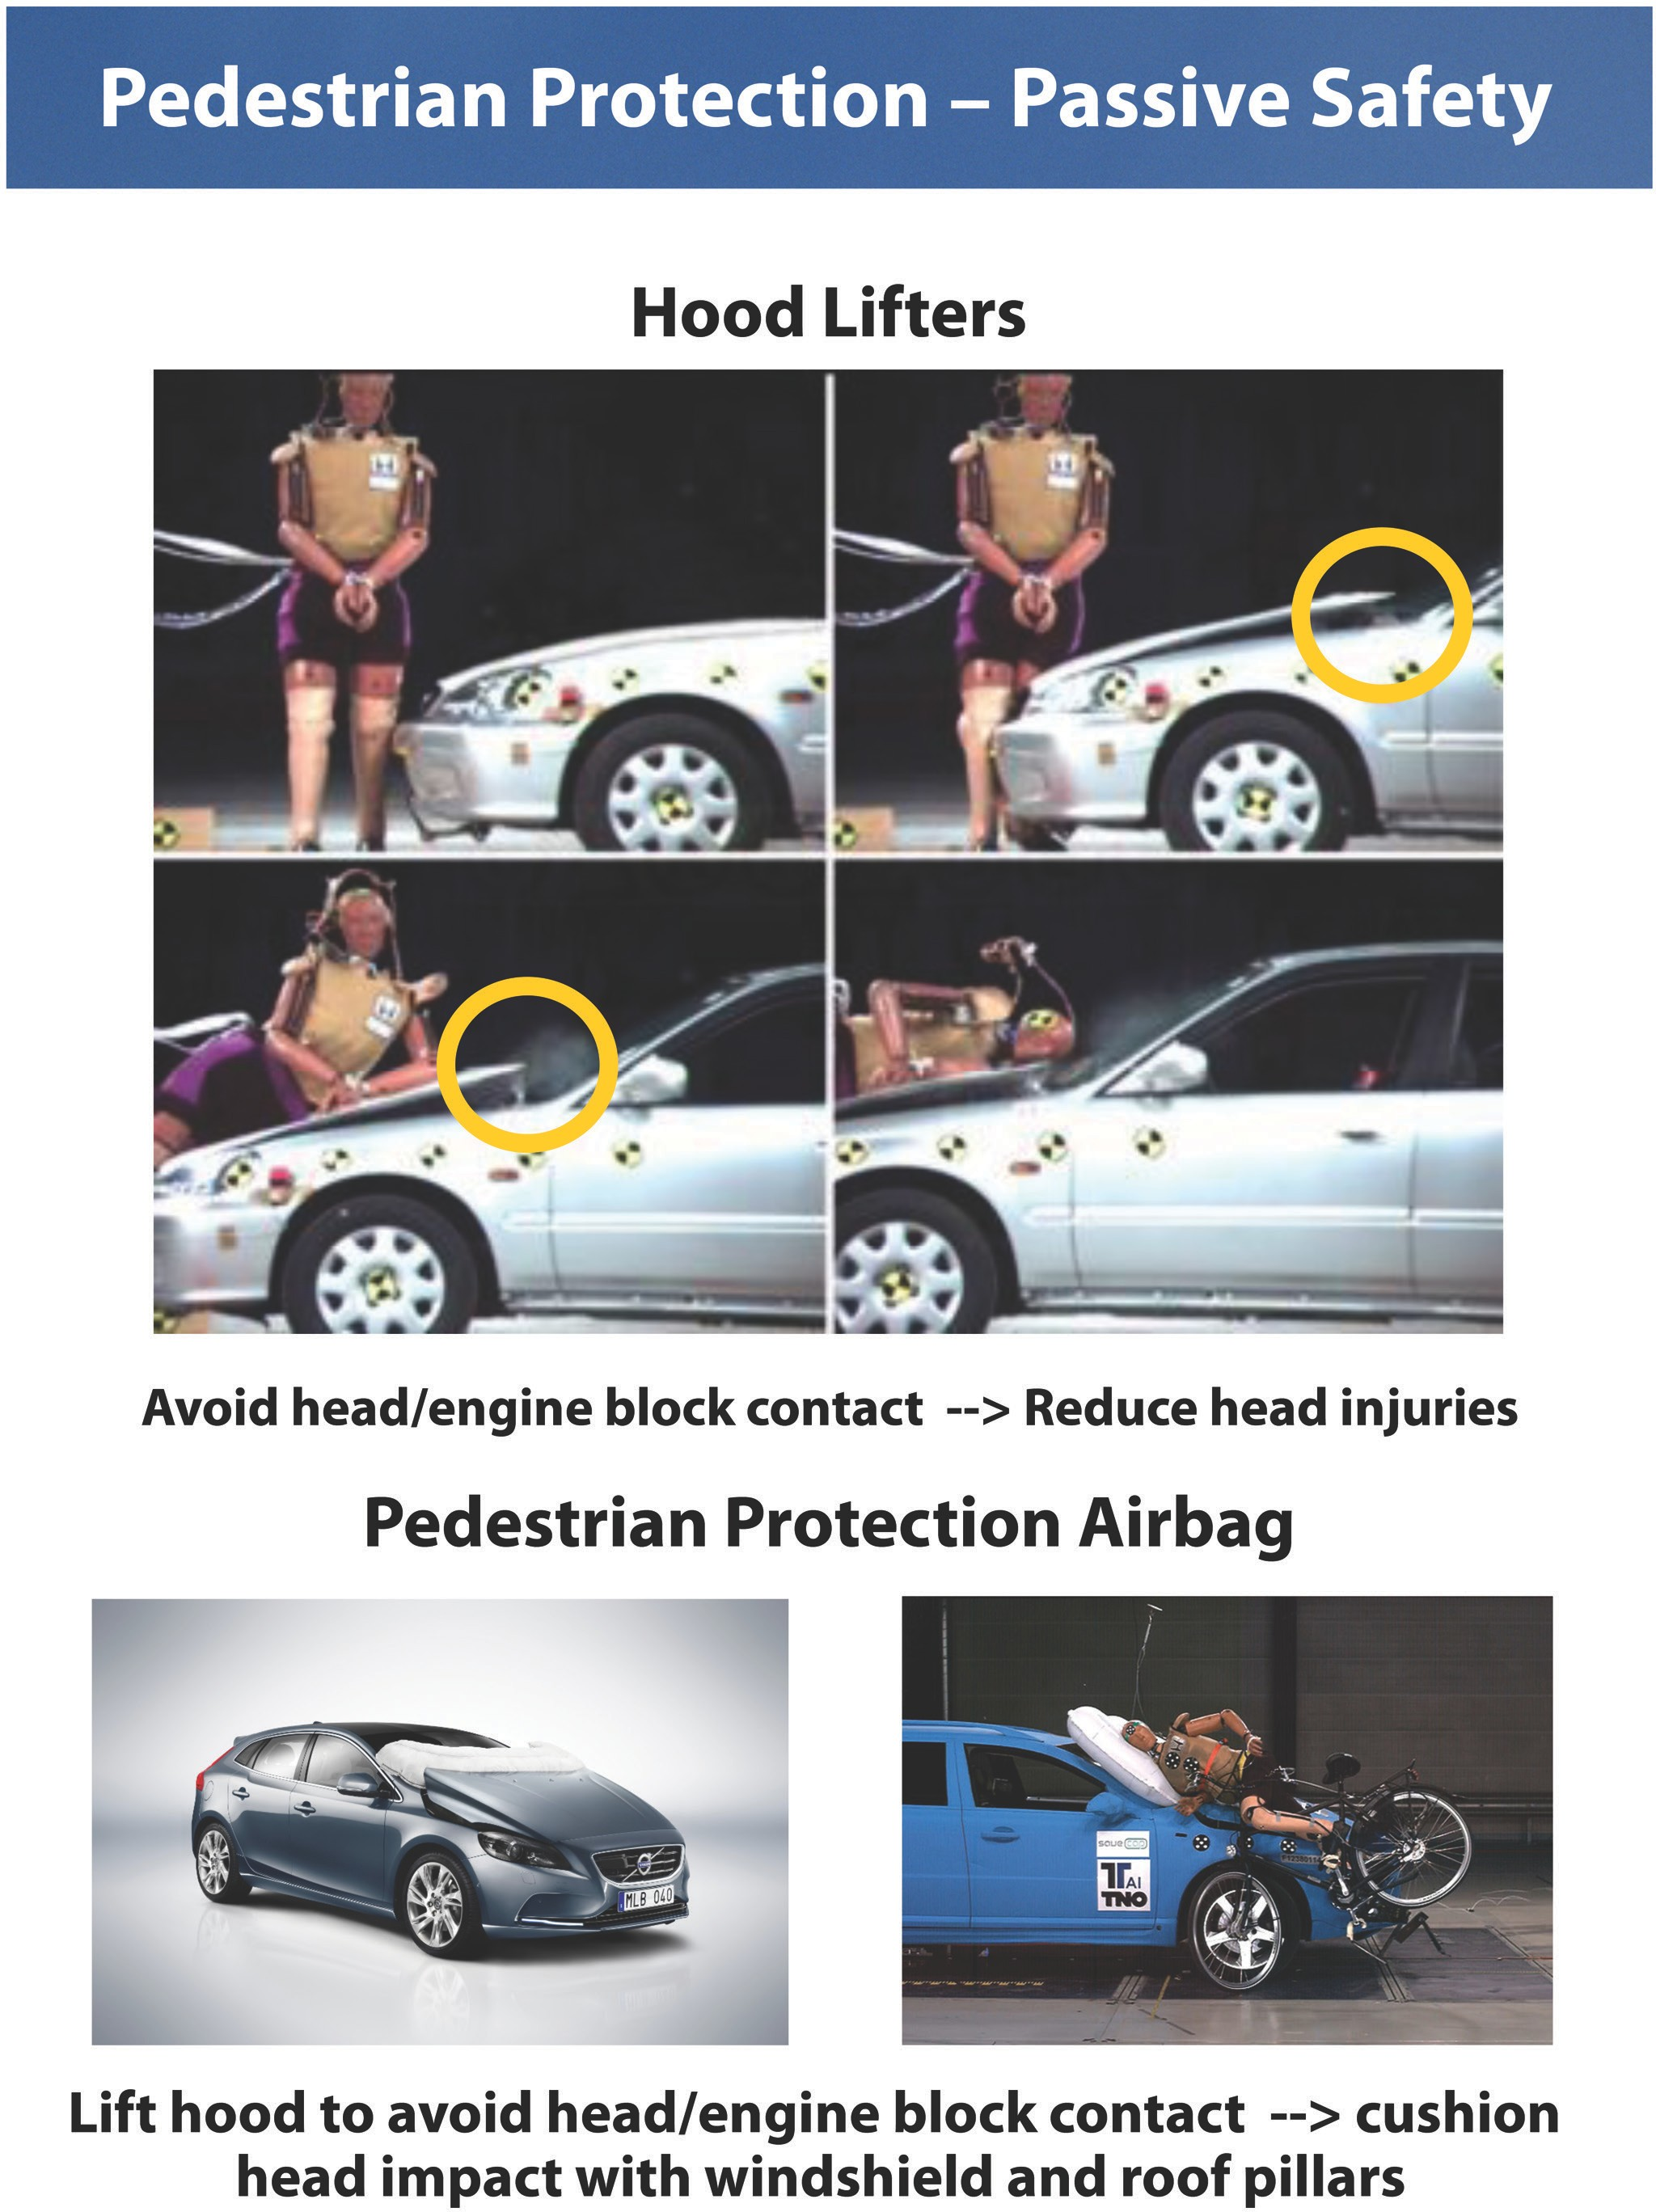

- Vehicles equipped with Adaptive Headlight Beam Switching systems can:
  - Improve visibility using high beams
  - Reduce glare by switching to low beams
  - Benefits both vehicle occupants and vulnerable road users such as pedestrians or cyclists

- Semi-automatic beam switching is offered on approximately 55% of all 2017 models
- No specific benefit studies exist, but NHTSA believes this technology could lead to reductions of injuries and fatalities, particularly for pedestrians
- ~ 3,500 pedestrian fatalities occurred in dark conditions
- Hypothetically, if this technology could reduce fatalities and injuries by up to 10%. This could reduce fatalities by up to ~ 961 and injuries by up to ~ 21,300, representing a potential $17.5 Billion annual cost saving to society.

Based on NHTSA VSL and ASC estimates

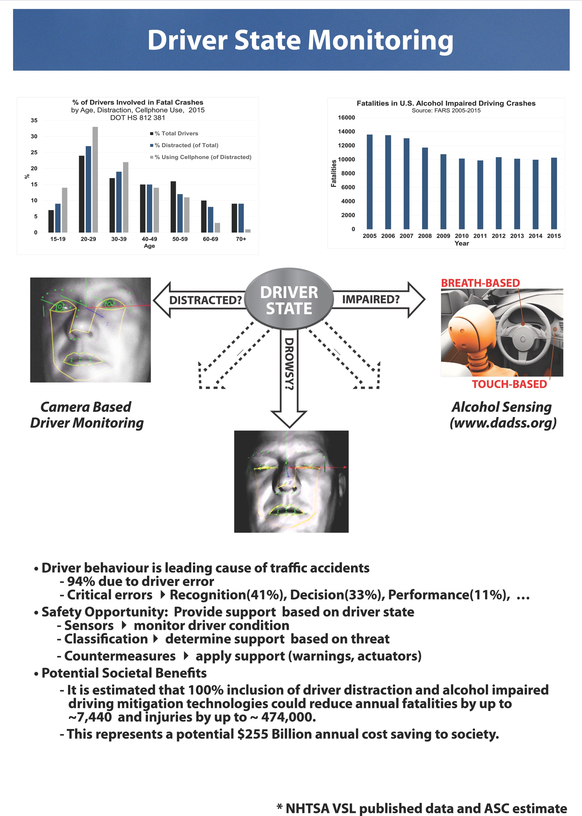

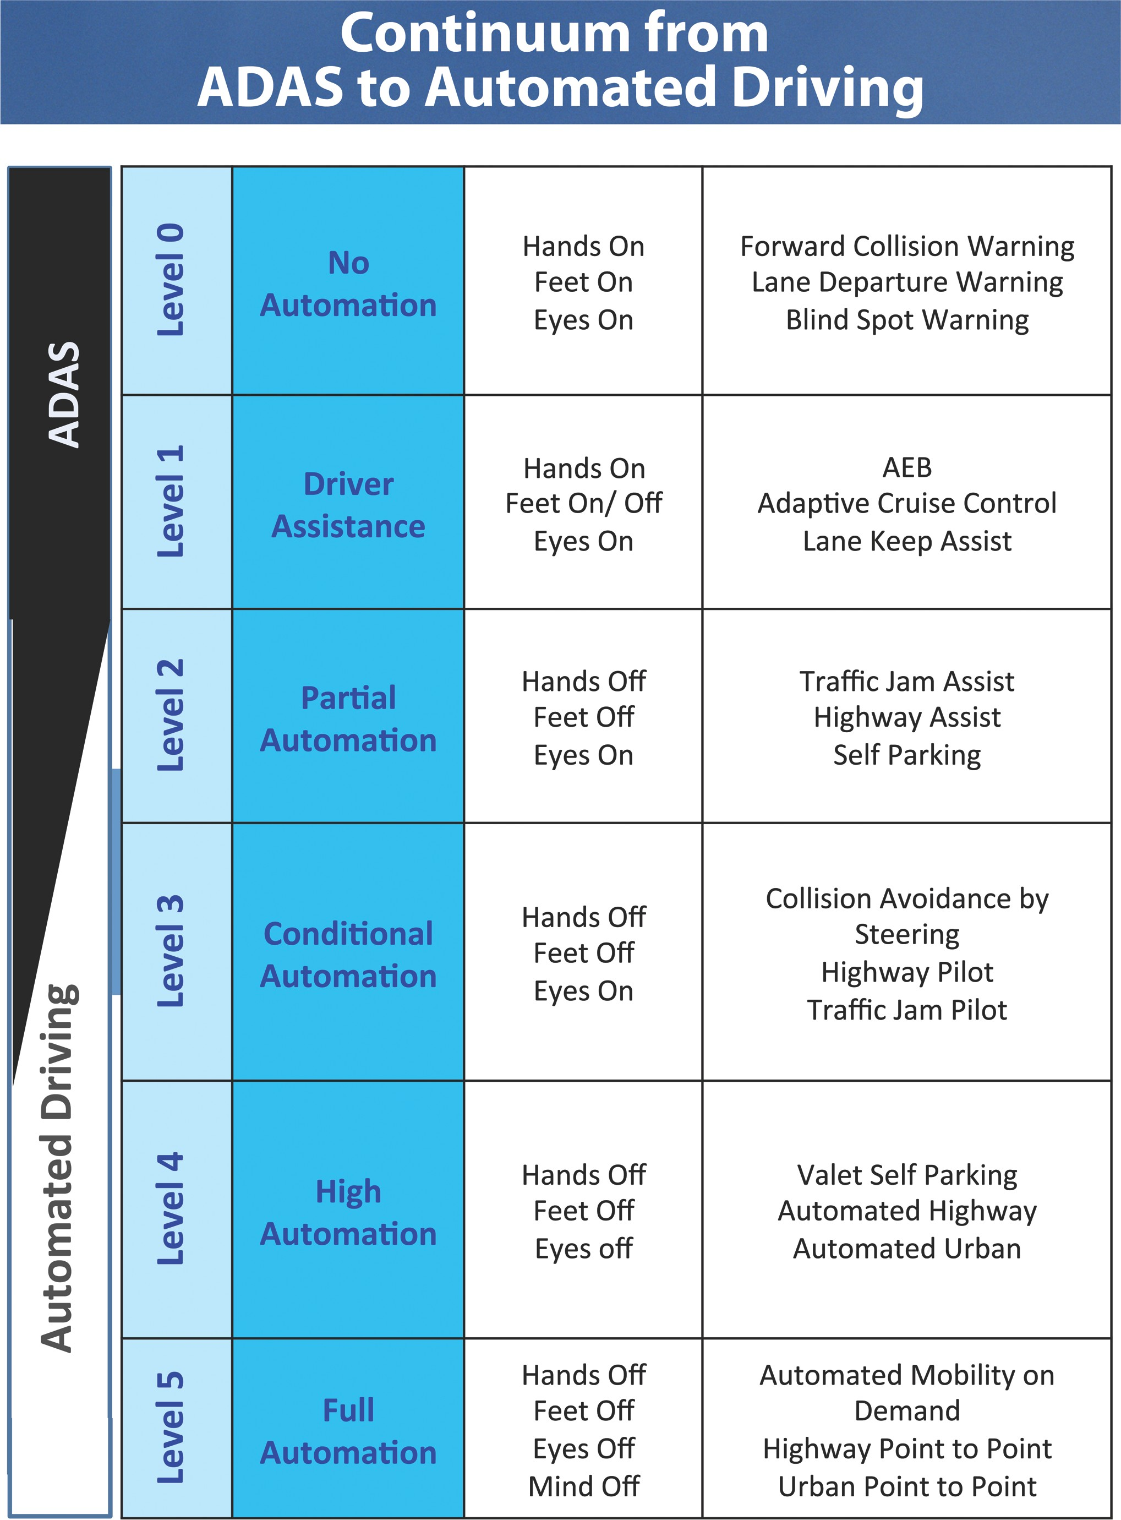

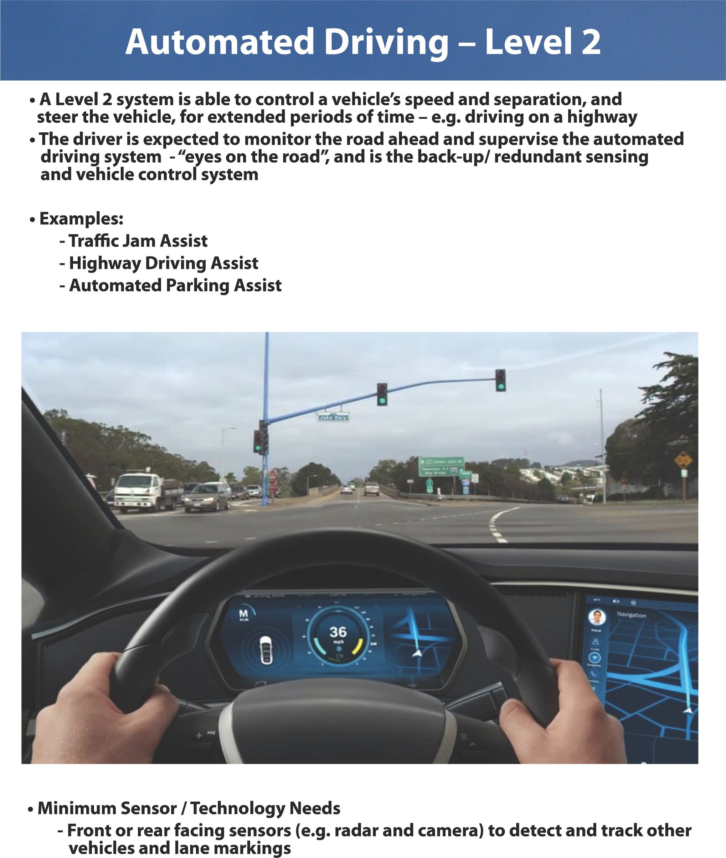

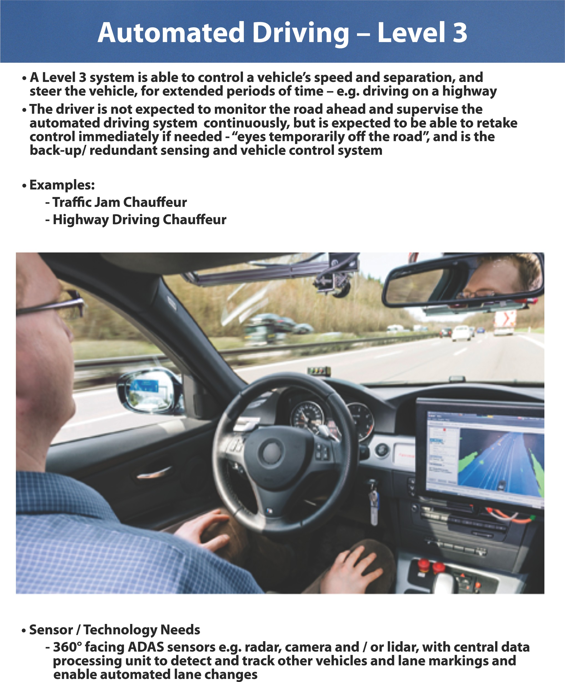

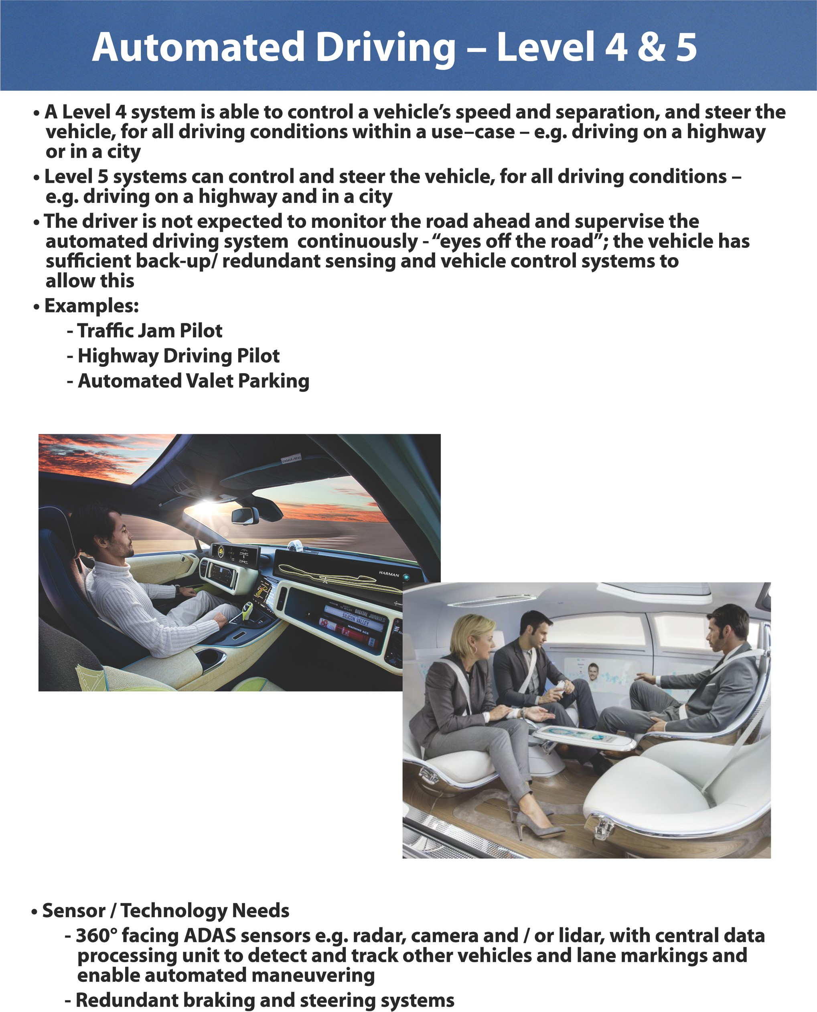

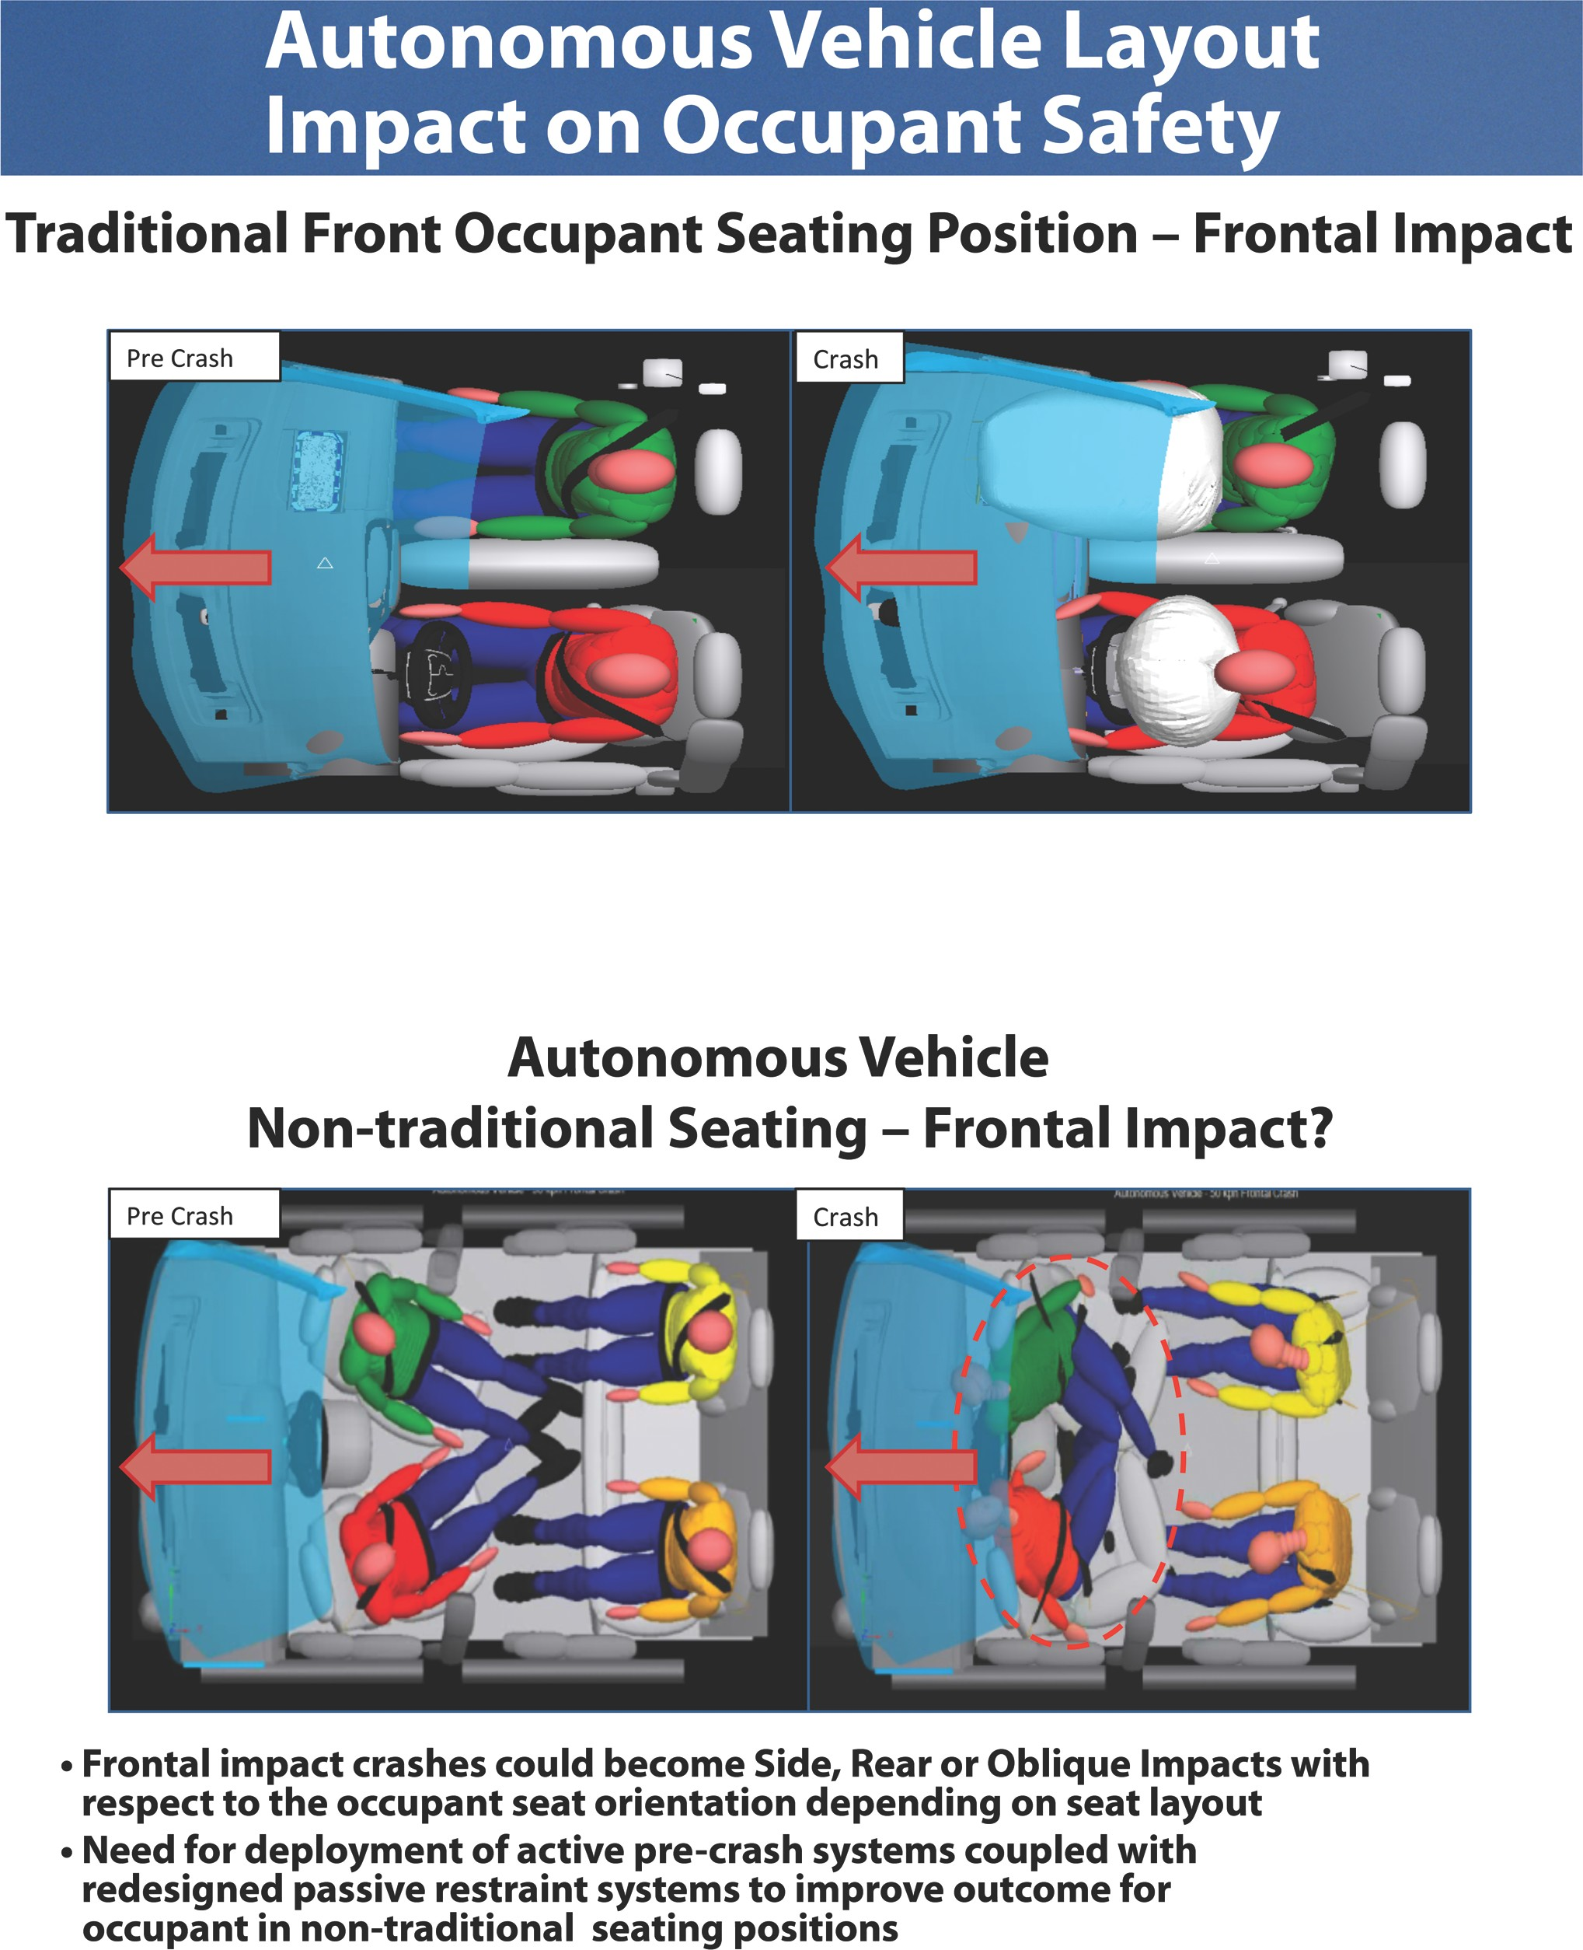

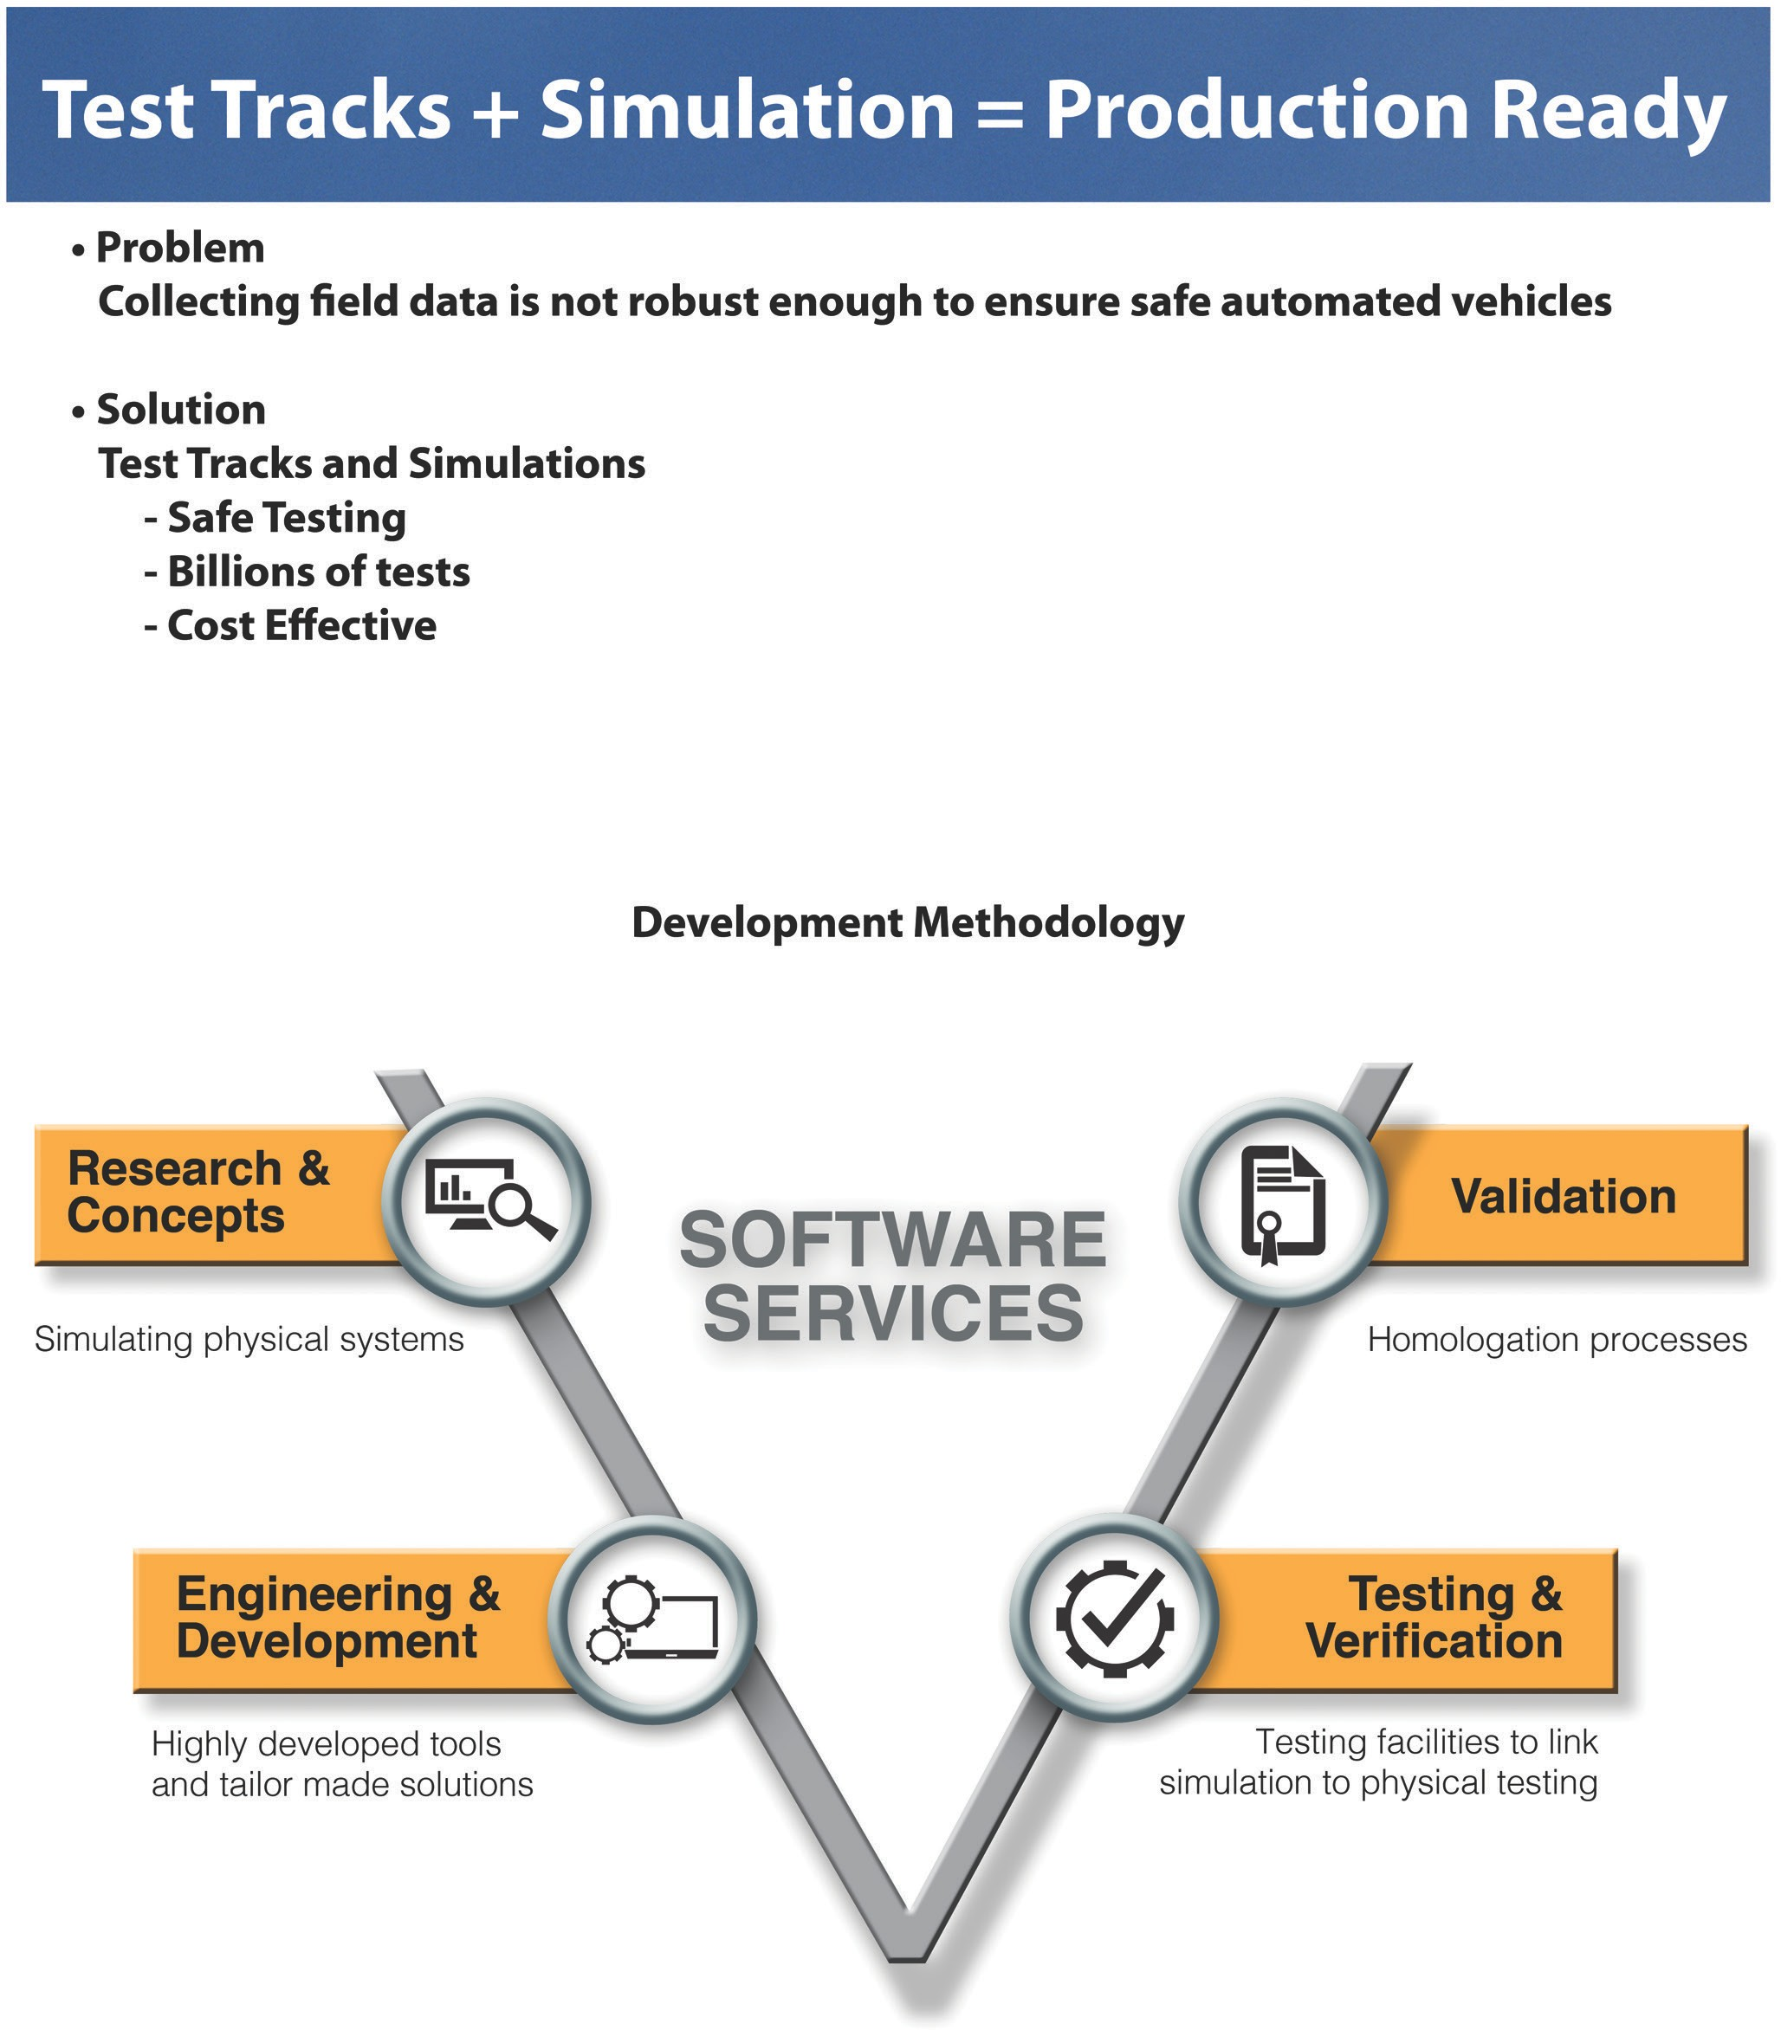

Automotive Safety Council
Prevent Protect Notify
